:
Mixd Reception ws
Mixed Reception Worksheet

Each group has one worksheet, so work on them together. Take notes on them and use them to help you solve the problem. We are going to collect them, but the task at hand is solving a murder, not filling out a worksheet.

While you watch the introduction video, note below your preliminary thoughts about which person/people you personally suspect, and why & how they might have done it.

While you interview suspects and gather evidence, make notes below about each suspect – do you personally suspect them? What reasons might they have had to commit the crime, and most importantly, how might they have done it? What were their means?

  Dr Yervin | Do you suspect this person?  What is their motive?  How might they have done it?
  Sam | Do you suspect this person?  What is their motive?  How might they have done it?
  Joanna | Do you suspect this person?  What is their motive?  How might they have done it?
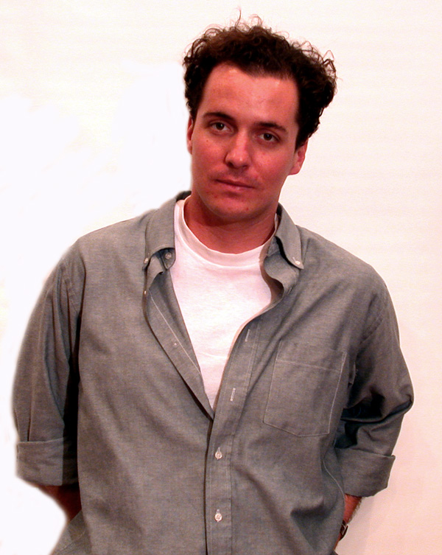  Vince | Do you suspect this person?  What is their motive?  How might they have done it?
  Nelson | Do you suspect this person?  What is their motive?  How might they have done it?

While you gather evidence, make notes below about how each piece of evidence might relate to a suspect, how it might have been used in the crime, etc.


Drug Info Sheet

Joanna’s Emails
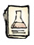
Anti-Toxin Report

Punch


Coroner’s Report

Nelson’s Journal

Peanuts


Peanut Pie

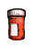
Nelson’s Pills


Pills from Joanna’s Office

Use this page for additional notes, calculations, and conclusions you make as you analyze the evidence and form your conclusion.

When you’re ready to report your findings, call a teacher over. They’ll interview you as you report the cause of death, the guilty party, and the evidence that lead you to your findings.

