**4 Types of Conversions to Learn: *1st balance the equation***

**# Conversions Factors**

1. Moles given 🡪 Moles wanted _______
2. Mass given 🡪 Moles wanted _______
3. Moles given 🡪 Mass wanted _______
4. Mass given 🡪 Mass wanted _______

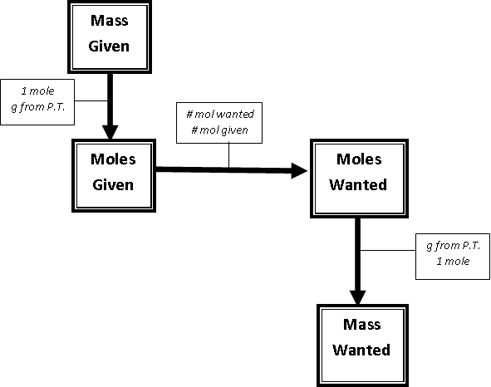

**Example Equation:**

Li3N -------->

1. If 4.5 moles of N2 are made, how many moles of Li3N decompose?

Type of stoichiometry problem:

# of conversion factors:

Given:

Wanted:

1. If 12.5 g Li is produced, how many moles of N2 are produced?

Type of stoichiometry problem:

# of conversion factors:

Given:

Wanted:

1. If 3.75 moles of Li3N are used, how many grams of N2 are made?

Type of stoichiometry problem:

# of conversion factors:

Given:

Wanted:

1. If 273.0 g of nitrogen is released, how many grams of Li3N decompose?

Type of stoichiometry problem:

# of conversion factors:

Given:

Wanted:

**Spiral Notes**

**To start Stoichiometry Problems:**

Read question and find

1. Balanced equation with correct diatomics and formulas
2. Find the Given (usually a number)
3. Find what is asked for ( ? )
4. To calculate stoichiometry problems
   1. Find # Moles (sometimes this is the given)
   2. Use Mole Ratio
   3. Find what is asked for ( ? )