I. Grade Level/Unit Number: 9-12 Unit 1

II: Unit Title: Chemtools- An Introduction to Chemistry

III. Unit Length: 6 days (on a 90 min. per day block schedule)

- Major Learning Outcomes:

Students should be able to:
- Define SI units for time, length, mass, and temperature (Kelvin and Celsius)
- Compare the derived units of density and volume
- Express numbers in scientific notation
- Perform operations in scientific notation
- Use dimensional analysis (factor label) to convert between units
- Define and compare accuracy and precision
- Use significant figures and rounding to reflect the certainty of data
- Use percent error to describe the accuracy of experimental data
- Create graphs to show patterns in data
- Interpret graphs
- Apply knowledge of laboratory safety and equipment
- Define physical change
- Recognize that melting points, boiling points, and solubility can be used to determine the identity of a substance
- Apply information (BP, MP, density) from the reference tables to identify an unknown
- Calculate density. (D=m/V)
- Apply the solubility rules
- Use graph of solubility vs. temperature to identify a substance based on solubility at a particular temperature. Use graph to relate the degree of saturation of solutions to temperature. Use graph to make simple calculations about solutions
- Describe physical equilibrium: liquid water-water vapor. Vapor pressure depends on temperature and concentration of particles in solution. (conceptual only – no calculations)
- Draw phase diagrams of water and carbon dioxide (shows how sublimation occurs). Identify regions, phases and phase changes using a phase diagram.
- Know that phase changes occur with changes in temperature and/or pressure. Relate change of phase to heating and cooling curves.

- Content Objectives Includes (with RBT Tags):

Objective Number | Objective | RBT Tag
2.04 | Identify substances using their physical properties:  - Melting points.  - Boiling points.  - Density.  - Solubility. | C3
2.08 | Assess the dynamics of physical equilibria.  - Interpret phase diagrams.  - Factors that affect phase changes. | B4

- English Language Development Objectives (ELD) Included:
NC English Language Proficiency (ELP) Standard 4 (2008) for Limited English Proficiency Students (LEP)- English Language learners communicate information, ideas, and concepts necessary for academic success in the content area of science.

Suggestions for modified instruction and scaffolding for LEP students and/or students who need additional support are embedded in the unit plan and/or are added at the end of the corresponding section of the lessons. The amount of scaffolding needed will depend on the level of English proficiency of each LEP student. Therefore, novice level students will need more support with the language needed to understand and demonstrate the acquisition of concepts than intermediate or advanced students.

- Materials/Equipment Needed

Activity | Materials
Penny & Nitric Acid Demo | 25 mL concentrated nitric acid  2- 500 mL flasks  5 – 10 drops of phenolphthalein  pellets of NaOH  rubber stoppers (1-hole & 2-hole)  rubber tubing  water  copper penny (pre-1982)
Red, White & Blue Demo | blue lamp oil (can use red lamp oil as a substitute)  whole milk  high sucrose syrup- clear (can use light corn syrup as a substitute)  red food coloring (can use blue food coloring as a substitute)  tall form 400 mL beaker (can use tall plastic or glass jar)
Brass Objects | 2 brass objects of varying sizes
Density Lab | can of diet soda  2-L graduated cylinder  can of non-diet soda balance  dropper pipette  distilled water  100-mL graduated cylinder  #2 rubber stopper (solid)

- Detailed Content Description:
Please see the detailed content description for each objective in the chemistry support document. The link to this downloadable document is in the Chemistry Standard Course of Study at:

http://www.ncpublicschools.org/curriculum/science/scos/2004/24chemistry

- Unit Notes:

This unit is focused on the tools that Chemistry students must possess to have success throughout the semester in this course. Students will develop abilities necessary to do and understand scientific inquiry. Students will be practicing the processes of science.

In each unit, Goal 1 objectives which relate to the process of scientific investigation are included. In each of the units, students will be practicing the processes of science: observing, hypothesizing, collecting data, analyzing, and concluding. The Goal 1 Objectives are as follows:

COMPETENCY GOAL 1: The learner will develop abilities necessary to do and understand scientific inquiry.
1.01 Design, conduct and analyze investigations to answer questions related to chemistry.  - Identify questions and suggest hypotheses.  - Identify variables.  - Use a control when appropriate.  - Select and use appropriate measurement tools.  - Collect and organize data in tables, charts and graphs.  - Analyze and interpret data.  - Explain observations.  - Make inferences and predictions.  - Explain the relationship between evidence and explanation.  - Identify how scientists share findings. | This goal and these objectives are an integral part of each of the other goals. In order to measure and investigate scientific phenomena, students must be given the opportunity to design and conduct their own investigations in a safe laboratory. The students should use questions and models to formulate the relationship identified in their investigations and then report and share those finding with others  Students will be able to:  - Identify questions and suggest hypotheses.  - Identify variables.  - Use a control when appropriate.  - Select and use appropriate measurement tools.  - Collect and organize data in tables, charts and graphs.  - Analyze and interpret data.  - Explain observations.  - Make inferences and predictions.  - Use questions and models to determine the relationships between variables in investigations.  - Identify how scientists share findings.

If a teacher follows this curriculum (s)he will have addressed the goals and objectives of the SCOS. However, teachers may want to substitute other activities that teach the same concept. The unit length has extra time built in for quizzes, going over homework, additional practice depending on the nature of the class, and assessment. Teachers should utilize the textbook as a resource by assigning homework each day and providing additional guided and independent practice.

Reference Tables:
The North Carolina Chemistry Reference Tables were developed to provide essential information that should be used on a regular basis by students, therefore eliminating the need for memorization. It is suggested that a copy be provided to each student on the first day of instruction. A copy of the reference tables can be downloaded at the following URL:

http://www.ncpublicschools.org/docs/curriculum/science/scos/2004/chemistry/referencetables.pdf

Essential Questions:
Essential questions for this unit are embedded within the unit. Essential questions are those questions that lead to student understanding. Students should be able to answer these questions at the end of an activity. Teachers are advised to put these questions up in a prominent place in the classroom. The questions can be answered in a journal format as a closure.

Safety: Students should wear chemical splash goggles during any lab activity involving chemicals. This includes household substances. It is extremely important for the safety and success of your students that you do ALL activities and labs prior to assigning them to students. At the beginning of each lab, the teacher should address any specific safety concerns relating to the activity.

Computer Based Activities:
Several of the recommended activities are computer based and require students to visit various internet sites and view animations of various biological processes. These animations require various players and plug-ins which may or may not already be installed on your computers. Additionally some districts have firewalls that block downloading these types of files. Before assigning these activities to students it is essential for the teacher to try them on the computers that the students will use and to consult with the technology or media specialist if there are issues. These animations also have sound. Teachers may wish to provide headphones if possible.

- Global Content: Aligned with 21st Skills:
One of the goals of the unit plans is to provide strategies that will enable educators to develop the 21st Century skills for their students. As much as students need to master the NCSOS goals and objectives, they need to master the skills that develop problem solving strategies, as well as the creativity and innovative thinking skills that have become critical in today’s increasingly interconnected workforce and society. The Partnership for 21st Century Skills website is provided below for more information about the skills and resources related to the 21st Century classroom.

http://www.21stcenturyskills.org/index.php?option=com_content&task=view&id=27&Itemid=120

NC SCS Chemistry | 21st Century Skills | Activity
 | Communication Skills
- - 1.03  2.04 & 2.08 | Conveying thought or opinions effectively | - Standard Notation Problems  - Factor-Label Problems  - Concept Map  - Solubility Curves
1.01 - 1.03 | When presenting information, distinguishing between relevant and irrelevant information
- & 1.03  2.04 & 2.08 | Explaining a concept to others | - Standard Notation Problems  - Factor-Label Problems  - Concept Map  - Solubility Curves
 | Interviewing others or being interviewed
 | Computer Knowledge
1.01 - 1.03 | Using word-processing and database programs
1.01 - 1.03 | Developing visual aides for presentations
1.01 - 1.03 | Using a computer for communication
 | Learning new software programs
 | Employability Skills
1.01 - 1.03, 2.04 & 2.08 | Assuming responsibility for own learning | - Brass Objects  - Density Lab
- - 1.03  2.04 & 2.08 | Persisting until job is completed | All activities
1.01 - 1.03 | Working independently
 | Developing career interest/goals
1.01 – 1.03 | Responding to criticism or questions
 | Information-retrieval Skills
 | Searching for information via the computer
 | Searching for print information
 | Searching for information using community members
 | Language Skills - Reading
2.04 & 2.08 | Following written directions | Most of the activities can be presented as opportunities for students to follow written directions. The teacher will have to work with most students to develop this skill over time. The following activities are well suited to developing skills in following directions:  - Scientific Notation  - Factor Labeling  - SI Conversion Practice  - Brass Objects  - Density Lab  - Solubility Practice
2.04 & 2.08 | Identifying cause and effect relationships | - Brass Objects  - Density Lab
 | Summarizing main points after reading
 | Locating and choosing appropriate reference materials
 | Reading for personal learning
 | Language Skill - Writing
 | Using language accurately
1.01 – 1.03, 2.04 & 2.08 | Organizing and relating ideas when writing | - Brass Objects  - Density Lab
- 1.03  2.04 & 2.08 | Proofing and Editing | All activities
 | Synthesizing information from several sources
 | Documenting sources
 | Developing an outline
1.03 | Writing to persuade or justify a position
 | Creating memos, letters, other forms of correspondence
 | Teamwork
1.01 – 1.03 | Taking initiative
- – 1.03  2.04 & 2.08 | Working on a team | - Brass Objects  - Density Lab
 | Thinking/Problem-Solving Skills
 | Identifying key problems or questions
- – 1.03  2.04 & 2.08 | Evaluating results | - Penny & Nitric Acid Demo  - Brass Objects  - Density Lab  - Red, White & Blue Demo
 | Developing strategies to address problems
 | Developing an action plan or timeline

ENGAGE: (20 min.)

The Penny and Nitric Acid Demo is a great way to kick off chemistry and to discuss laboratory safety. (As part of the demo, the teacher should model lab safety). Students could be asked to record observations during the demo or simply call them out verbally. The teacher can explain that this activity includes MANY of the concepts they will learn in chemistry. No explanations should be made – only observations. The teacher should set up the demo as indicated by the diagram:

Essential Question:
Why is it important to be safe in the laboratory? Give examples of lab safety.

Language (ELP) Objective for LEP Students:
- Student will draw and label the set up for the Penny and Nitric Acid Demo
- Student will record in paragraph form their observation of the steps carried out demo and their explanation as to what happened as a conclusion
- Student will write a list of “5* lab safety rules, explain verbally their importance, and share their ideas with a partner or whole class. *(number of rules may vary according to the level of LEP student)

Penny and Nitric Acid Demo

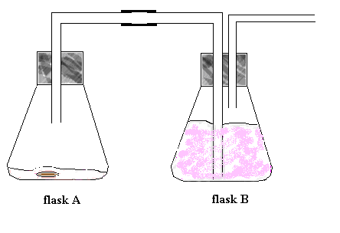
- Put 25 mL concentrated nitric acid into flask A (500 mL).
- Fill flask B (500 mL) with 300-350 mL of water. Add 5 – 10 drops of phenolphthalein and 1 pellet of NaOH. Stopper flask B.

Procedure:
- Drop a copper (pre-1982) penny into the acid in flask A and stopper immediately.
- NO₂ gas forms. It is very irritating to the eyes, mucus membranes and lungs. Make sure the stoppers are securely in place.
- The water bath should remove almost all of the NO₂ gas.

Following the demo, the teacher should provide each a copy of Safety in the Chemistry Classroom and the Chemistry Lab Safety Contract. Thoroughly explain lab safety and have both students and parents sign the contract.

SAFETY IN THE CHEMISTRY LABORATORY

Chemistry is a hands-on laboratory class. Safety in the lab is our top priority. Below, you will see a list of the most important lab safety rules. These rules MUST be followed at all times. After studying the following rules, you and your parent or guardian will be asked to sign a safety contract before you can participate in the laboratory. Keep these safety rules in your notebook as a constant reminder of their importance.

1. Conduct yourself in a responsible manner at all times in the lab. No horseplay, practical jokes, or pranks allowed.
2. Follow all written and verbal instructions carefully. Ask your teacher if you do not understand any part of the procedure.
3. Never work in the lab without your teacher present.
4. Do not eat, drink, or chew gum in the lab.
5. Never do anything that is not called for in the laboratory procedures or by your teacher. Carefully follow all instructions.
6. Be prepared for your work in the laboratory. Read all procedures thoroughly before entering the lab.
7. Work areas should be kept neat at all times.
8. Keep aisles clear. Push your stool under the table when not in use.
9. Know the location of all safety equipment. Know where the exits are.
10. Dispose of all chemical waste properly, according to your teacher’s direction.
11. Wash your hands with soap and water after performing each experiment.
12. Anytime heat, chemicals, or glassware are used, students must wear laboratory goggles.
13. Contact lenses should not be worn in the laboratory unless you have permission from your teacher.
14. Report any accident or spill to your teacher immediately.
15. Check the label on chemical bottles twice before removing any of the contents.
16. Always add acid to water when diluting.
17. Never handle broken glass with your bare hands.
18. Handle glass that has been heating with great care. Remember: hot glass looks like cold glass.
19. Never use chipped or cracked glassware.
20. Do not immerse hot glassware in cold water. It may shatter.
21. Exercise extreme caution when using a gas burner. Take care that hair, clothing and hands are a safe distance from the flame at all times. Do not put anything in the flame unless instructed to do so!
22. Never leave a lit burner unattended. Always turn the burner/ hot plate off when not in use.

23. Do not point the open end of test tube being heated toward yourself or anyone else. Never look into a container that is being heated.
24. Determine if an object is too hot to touch by bringing it close, but not touching, the back of your hand. If you feel heat radiating, allow it to cool for a longer period of time.

CHEMISTRY LAB SAFETY CONTRACT

I, ____________________________ have read and agree to follow all of the safety rules set forth by my teacher. I realize that I must obey these rules to ensure my own safety, and that of my classmates and teacher. I will cooperate to the fullest extent with my teacher to maintain a safe lab environment. I will also closely follow the oral and written instructions provided by my teacher. I am aware that any violation of this safety contract that results in unsafe conduct in the laboratory or misbehavior on my part, may result in being removed for the laboratory, detention, receiving a failing grade, and/or dismissal from this class.

________________________________ Student signature

________________________________ Date
Dear Parent or Guardian:

Your signature on this contract indicates that you have read the Safety in the Chemistry Laboratory rules and are aware of the measures taken to ensure the safety of your son/daughter in the Chemistry laboratory. Please instruct your child to uphold this agreement to follow these rules and procedures in the lab.

________________________Parent/Guardian signature

________________________Date

EXPLORE: (15 min.)

Students will be familiar with scientific notation, but will need a refresher. Allow students to explore the notes and complete the practice problems on Scientific Notation/Exponential Notation.

Essential Question:
Why do we use scientific notation in chemistry?

Scientific Notation/Exponential Notation
- Scientific Notation was developed in order to easily represent numbers that are either very large or very small.
- Scientific Notation is based on powers of the base number 10.
- Examples:
The number 200,000,000,000 stars in scientific notation is written as 2 x 10¹¹ stars

The number 0. 000,006,645 kilograms in scientific notation is written as 6.645 x 10⁻⁶ stars

- The first number 6.645 is called the coefficient.
- The coefficient must be greater than or equal to 1 and less than 10.
- The coefficient contains only significant digits.
- The second number is called the base.
- The base must always be 10 in scientific notation.

- The number -6 is referred to as the exponent or power of ten.
- The exponent must show the number of places that the decimal needs to be moved to change the number to standard notation.
- A negative exponent means that the number written in standard notation is less than one.

To Change from Standard Form to Scientific Notation:
  - Place decimal point such that there is one non-zero digit to the left of the decimal point.
  - Count number of decimal places the decimal has "moved" from the original number. This will be the exponent of the 10.
  - If the original number was less than 1, the exponent is negative; if the original number was greater than 1, the exponent is positive.
Examples: Write the following numbers in scientific notation.
- 96,400

- 0.361

- 0.0057300

- 6,587,234,000

- 8.00

To Change from Scientific Notation to Standard Form:
- Determine the number of places the decimal must be moved from the exponent.
- Decide if the standard form will be a number greater than one or less than one.
- Move the decimal in the coefficient adding place holders if necessary.
Examples: Write the following numbers in standard notation.
- 3.97 x 10³
- 8.862 x 10⁻¹
- 6.251 x 10⁹
- 512 x 10⁻⁸
- 3.159 x 10²

EXPLAIN: (15 min.)
Upon completion of the standard notation problems, allow the students the opportunity to explain how they derived their answers. This can be done by conducting a jigsaw activity or by allowing students to go to the board/overhead.

The Factor Label Method: (15 min.)

Students will need to be able to use the factor label method to solve problems throughout the course. You may need to explain the significance of factor labeling (that it will be used throughout the course).

Essential Question:
What is the purpose of factor labeling in chemistry and how can it be used outside of the chemistry classroom?

The Factor Label Method:
The most important mathematical process in chemistry!

What does “Factor-Label” mean?
- Factors are the numbers
- Labels are the units

When using the factor-label method, problems consist of three parts:
- a known beginning – GIVEN
- a desired end – WANTED
- a connecting path – CONVERSION FACTORS

What are CONVERSION FACTORS?
  - Equalities
  - Examples:
    - 12 in = 1 ft
    - 1 mi = 5280 ft

  - Conversion factors will be written as “tops & bottoms”
  - Examples:
    - 12 in
1 ft
    - 1 mi
5280 ft

  - Conversion factors can be “flipped” depending on which unit needs to be canceled.

Examples
- Calculate the number of seconds in one day.

1 day 24 hr 60 min 60 sec
1 day 1 hr 1 min

- At a meeting, 28 people are each given 3 pens. If there are eight pens in one package, priced at $1.88 per package, what is the total cost of giving away the pens?

28 people 3 pens 1 pkg $1.88
1 person 8 pens 1 pkg

ELABORATE: (40 min.)

The following activity (Factor-label Problems) will elaborate and provide practice following the discussion on factor labeling. Allow students to explore the notes and complete the practice problems.

Essential Question:
What is the purpose of factor labeling in chemistry and how can it be used outside of the chemistry classroom?

Factor-label Problems

1. How many basketballs can be carried by 8 buses? (1 bus=12 cars, 3 cars=1 truck, 1000 basketballs=1 truck)

2. A chemistry instructor provides each student with 8 test tubes at the beginning of the year. If there are 28 students per class, how many test tubes are required for three chemistry classes?

3. What is the cost in dollars for the nails used to build a fence 125 meters long if it requires 30 nails per meter? There are 40 nails per box at a cost of 75 cents per box.

4. Before the use of money, people bartered for goods they needed. If 25 chickens could be traded for 1 pig, 10 pigs exchanged for 1 cow, and 2 cows for 3 horses, how many horses could be exchanged for 500 chickens?

5. You are painting a room and find that the paint you are using will cover 75.0 square feet per quart. If the paint costs $8.00 per gallon, what would be the cost to paint a room containing 2000 ft²?

6. Make the following conversions:
a.) 10 hours to seconds
b.) 115 inches to yards
c.) $25 to nickels
d.) 10 weeks to minutes

7. A golf ball weighs 4 oz. How many golf balls would there be in a 2.5-ton sample of golf balls, assuming each golf ball had the same weight?

8. Making macaroni jewelry was therapeutic for Bobby. If he spent 50 cents per necklace and he made 1324 necklaces per month, what would his expenditures be for 5 years?

9. Rakeemah loved to eat pickles. She averaged eating 7.2 pickles per meal – every meal (3 meals per day) for a year. If pickles were sliced into 4 slices, how many pickle slices would she eat in a decade?

10. A car is traveling 65 miles per hour. How many feet does the car travel in one second?

11. Calculate the number of lab reports Mr. Jones will have to grade during the school year if his students each do 15 experiments. Mr. Jones had 4 classes of 24 students each.

12. Mr. Jones plans to do an experiment with his classes, which requires 2 test tubes per student. How many dozens of test tubes will Mr. Jones need to supply to the students in his 4 classes of 24 students each?

13. Determine the number of 4-ounce bottles of sodium chloride Mr. Jones will need to do the experiment mentioned in Problem 12 if each student needs 14.7 grams of sodium chloride. (1 oz= 29.5 grams)

14. If you could count at the rate of 2 numbers every second, how many days would it take you to count to 1 million?

EXPLAIN: (15 min.)

Upon completion of problems, allow the students the opportunity to explain how they derived their answers. This can be done by conducting a jigsaw activity or by allowing students to go to the board/overhead.

Review of the SI System (Metrics): (20 minutes)

Students will be familiar with the metric system from previous science courses, but will most likely need a refresher. The teacher should use the factor label method along with the exponent values for each of the prefix to model metric conversions. (Giga, Mega, kilo, deci, centi, micro, nano, pico). Include the cubed units for volume (cubic centimeter, cubic decimeter.)

Essential Question:
What is the SI system and why is it important in science?

ELABORATE: (30 min.)
The following activity (SI Conversion Practice) will allow for elaboration and provide guided or independent practice following the discussion on the SI System of Measurement.

Essential Question:
What is the SI system and why is it important in science?

SI Conversion Practice
The following measurements were made. Express using scientific notation for one response and the most proper unit prefix for the second response.
1. 0.000006 m ______________________ ______________________
2. 19000000 g ______________________ ______________________
3. 0.000000000006 m______________________ ______________________
4. 0.0004 mol ______________________ ______________________

Make the following unit conversions: (SHOW YOUR WORK!!)
5. 0.006 pm to mm ______________________

6. 1.5 x 10⁻⁶ g to ng ______________________

7. 100 kg to g ______________________

8. 100 dg to kg ______________________

9. 86.6 cg to ng ______________________

10. 1200 cm to pm ______________________

11. 300 cm³ to dm³ ______________________

12. 8.5 x 10⁻⁴ dm³ to cm³ ______________________

Kelvin and Celsius: (10 minutes)

As part of the SI System, the teacher should include the SI unit for temperature. Use the graphic below to relate and explain the Kelvin and Celsius to the Fahrenheit scale. Provide guided practice for converting between the Celsius and Kelvin scales. (NO Fahrenheit conversions).

Essential Question:
What is the relationship between the Celsius and Kelvin scale?

Temperature Scale- Fahrenheit, Celsius & Kelvin

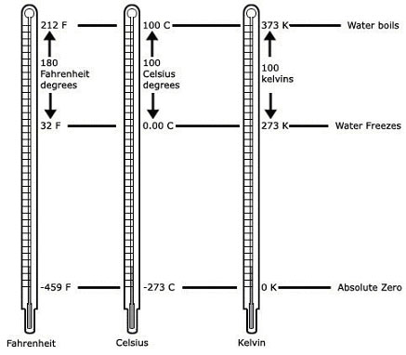

(30 minutes)
EVALUATE:

This activity (Chemtools Practice #1) provides practice for scientific notation, metrics, and temperature conversions. This can be used as a type of formative assessment to evaluate how the student is doing with these concepts. It can be used as a homework or in-class assignment.

Essential Question: What are conversion factors and how can they be used to convert from unit to another?
Chemtools Practice #1

Name ________________________________

Put the following in scientific notation:
1. 0.000003 = ___________________

2. 822000000 = ___________________

3. (9.3 x 10¹³) (1.23 x 10¹⁰) = ___________________

4. (6.53 x 10⁻¹⁶) (2.93 x 10⁻⁴) = ___________________
(2.4 x 10⁻¹⁷)

Make the following conversions: (SHOW YOUR WORK!!)
1. 2.33 dm = _____________________mm
2. 1.4 kg = _____________________pg
3. 44.5 nm = _____________________cm
4. 145g = _____________________mg
5. 229 K = _____________________ºC
6. 20.5 K = _____________________ºC
7. 188 ºC = _____________________K

ENGAGE: (5 min.)

In this demo (Red, White and Blue II), the teacher will create a density column and is used to engage students in the concept of density. The activity mentions “likes dissolves like”. This will not be discussed at this point in the course. The teacher should mention that the fact that the 3 substances do not mix is another concept that will be learned later in the course. This demo can be revisited in the unit where polarity is discussed. Students will remember this one.

Essential Question:
How does density determine the layering of a liquid mixture?

Countertop Chemistry Experiment 18
Red, White and Blue II
Countertop Chemistry activity used by permission of The Science
House at NC State University, www.science-house.org

This colorful demonstration shows the rule "likes dissolve likes" by combining three immiscible (insoluble) liquids to create a density column.
Materials | Substitutions
blue lamp oil | red lamp oil
whole milk
high sucrose syrup-clear | light corn syrup
red food coloring | blue food coloring
tall form 400 mL beaker | tall plastic or glass jar
Procedure
- Wrap the outside of the glass loosely with aluminum foil so that you can pour your liquids into the glass and can uncover the glass easily by lifting the foil off.
- Add several drops of red food coloring to the Karo Syrup and invert several times to mix.
- Pour the three liquids -red colored syrup, milk, blue lamp oil- into the glass in any order. Pour slowly so that not too much mixing occurs.
- Ask the students what color will result from mixing red, white, and blue. Then lift the aluminum foil mask to reveal three layers, with the red syrup on the bottom, white milk over the syrup, and blue lamp oil on top.
Teacher's Notes
Because the milk is not exposed to air, it will not spoil in the density column. Therefore, you can keep this demo for weeks. All substances can go down the drain with copious amounts of water for disposal.
Most dollar (dime) stores (like Walmart or K-Mart) will carry lamp oil. The colors available often depend on the season. You can color your syrup differently to adjust for the color of the lamp oil that is available.
Immiscible liquids don't mix because of differing densities, molecular polarities, or both. The lamp oil has a density < 1 g/mL and is a nonpolar molecule. The milk has polar and nonpolar characteristics but since 80% of milk is water, it is mostly polar. The syrup has very little water in it and has a density of 1.37 g/mL.

(45 min.)
EXPLORE:
Brass Objects is an inquiry activity that allows students to explore density. The teacher will need to provide 2 brass objects of different sizes.
Essential Question:
How are the brass objects similar and different?

Brass Objects

- Examine the two brass objects located in your tray. Describe how they are similar and how they are different. Record your observations below.
- Similarities
- _______________________
- _______________________
- _______________________
- Differences
- _______________________
- _______________________
2. Are they the same size? (volume) ___________
If not, arrange them in order from smallest to largest.

3. Do they have the same mass? _______________
If not, arrange them in order from lightest to heaviest.

4. How does the order of the volume in step 2 compare to the order of the masses in step 3?

5. Measure the volume of each object and record the data (in mL) in the table below:

Object | Volume

1 - Smallest

2 - Largest

6. Measure the mass of each object and record the data (in grams) in the table below:
Object | Mass

1 - Lightest

2 - Heaviest

- Now combine the tables from steps #5 and #6 above into a combined mass and volume table below:

Objects | Mass | Volume
1
2

- What can you infer from the data recorded in step #7 above?_____________________________________________________________
____________________________________________________________________________________________________________________________________________

- Discuss with the other members of your group how the volume and mass of a specific object might be related. Comprise a one-sentence statement that best describes this relationship._________________________________________________________

______________________________________________________________________

Concept Introduction

During your exploration activity, you observed how the masses of two samples of the same material changed as their volumes changed. Data representing these changes were then recorded in a table (step #7) that showed how the changes in the volumes from the two samples were accompanied by similar changes in their masses. This unique relationship between the mass and volume of any specific kind of material is called density. Scientifically, this relationship is defined as the mass per unit volume of the material and expressed in the form of an equation as follows:

Density = mass or D = m
volume v

The density of a material is found by dividing the mass of a sample by its volume. For example, if an object has a mass of 10g and a volume of 2 mL (or cm³) its density is calculated as follows:

D = 10g

2 mL

D = 5 g/mL

Note: The density must be expressed as mass per unit volume. In this example, 5 grams per mL (cm³) is the density of the material.
- Now you are ready to calculate the density for each of the samples you worked with during your exploration activity. Using the data recorded in step #7 of your exploration, calculate the density for each sample and record below:
Sample #1:

D = ______________(in pen)

Sample #2

D = _______________(in pen)

- Compare the densities. Are they the same, nearly the same, or very different? ________________________________

- Why do think the densities are like this? ___________________________________________________________________

- Water has a density of 1g/cm³, will these objects float or sink?_____________Why?_________________________________

- Your teacher will now tell you the density brass. To calculate the percentage error of each of your samples, use the formula:

Your density
X 100 =
Real density (literature value)

Sample 1: % error_____________________

Sample 2: % error_____________________

Overview of Matter: (30 min.)

Students will be familiar with matter from previous science courses, but will most likely need a refresher. This PowerPoint provides the notes for an overview. The teacher should explain and emphasize the physical properties. The PowerPoint includes practice using the reference tables. Students will determine the state of matter of substances at certain temperatures using melting and boiling points. Practice using the density equation is embedded within the presentation. The teacher should tie these problems back to the lab.

Essential Question:
Describe the changes of state including in matter and how you would determine the state of matter at a specific temperature.

Language (ELP) Objectives for LEP Students:
- Student will complete matter flowchart handout as teacher presents PowerPoint on the properties of matter
- Students should define each key term in journal or on back of handout.

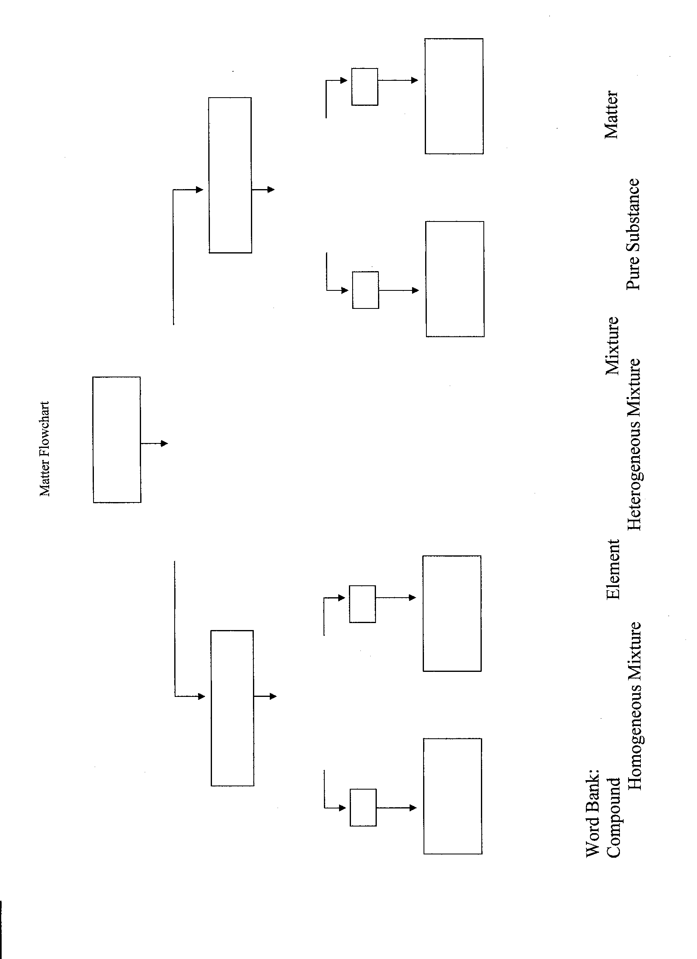

Phase Diagrams: (15 min.)

Begin by showing students phase diagrams and explain how to interpret the diagrams.
- A phase diagram is a graphical way to depict the effects of pressure and temperature on the phase of a substance.
- Identify and define phase regions, triple point, points where to phases are in equilibrium with one another, normal melting/freezing point and normal boiling point.

Phase Diagrams for water
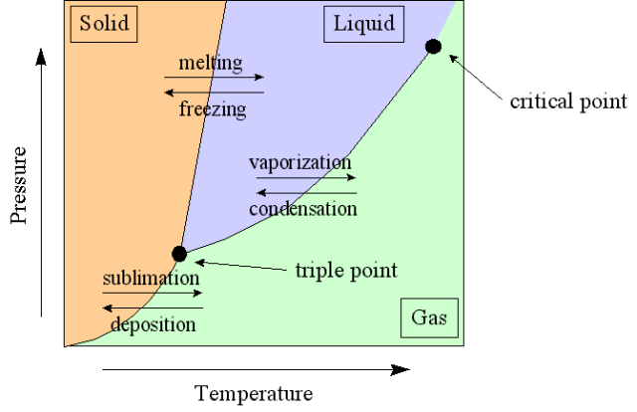

http://www.its.caltech.edu/~atomic/snowcrystals/ice/ice.htm

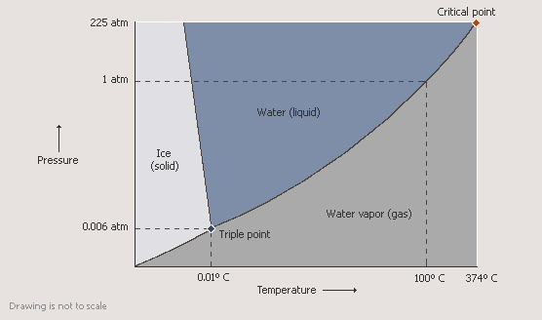

http://encarta.msn.com/media_461541579/Phase_Diagram_for_Water.html

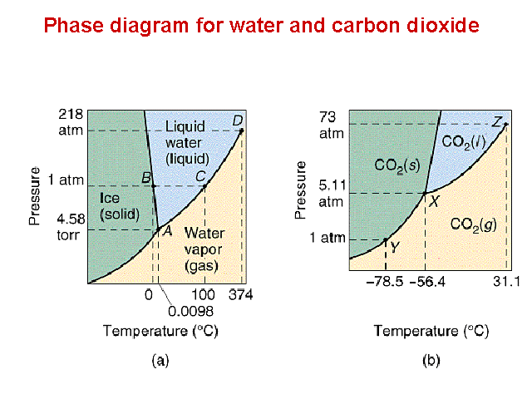
The document below provides graphics for presenting phase diagrams.
Essential Question:
What is a phase diagram?

http://www.chem.neu.edu/Courses/1131Tom/Lecture25/sld007.htm

Unit 1 - Phase Diagram Practice

For each of the questions on this worksheet, refer to the phase diagram for mysterious compound X.
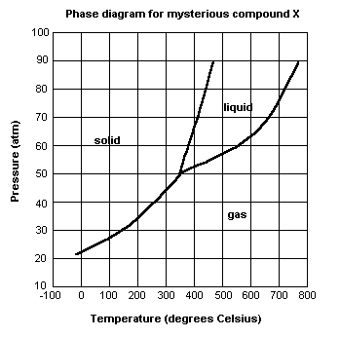

1) If you were to have a bottle containing compound X in your closet, what phase would it most likely be in?
_____________________

2) At what temperature and pressure will all three phases coexist?

_____________________________________

3) If I have a bottle of compound X at a pressure of 45 atm and temperature of 100⁰ C, what will happen if I raise the temperature to 400⁰ C? (Specify phase change.)
_____________________________________

4) If compound X is nontoxic, would you be able to drink it in the liquid form?

_____________________________________

5) If I have a bottle of compound X at a pressure of 70 atm and temperature of 750⁰ C, what will happen if I lower the temperature to 600⁰ C? (Specify phase change.)
Teacher Guide- Phase Diagram Worksheet

For each of the questions on this worksheet, refer to the phase diagram for mysterious compound X.
1) If you were to have a bottle containing compound X in your closet, what phase would it most likely be in?

gas

2) At what temperature and pressure will all three phases coexist?

350⁰ C, ~51 atm

3) If I have a bottle of compound X at a pressure of 45 atm and temperature of 100⁰ C, what will happen if I raise the temperature to 400⁰ C?

It will sublime

4) If compound X is nontoxic, would you be able to drink it in the liquid form?

No, it would be too hot

- If I have a bottle of compound X at a pressure of 70 atm and temperature of 750⁰ C, what will happen if I lower the temperature to 600⁰ C?

It will condense

EXPLAIN: (30 min.)

Allow students the opportunity to share answers with the class. Also, construct a concept map containing the topics discussed up to this point in the unit.

ELABORATE: (40 min.)

In this activity (Density Lab), students will determine the density of various objects including a diet soda and a regular soda. Teacher notes are provided below.

Essential Question:
What is density?

Density Lab Teacher Notes
Materials:

**See lab directions.
**Instead of a 2-L graduated cylinder, you can use any container large enough to contain a soda can. An empty aquarium works well. Fill the container with water and place it in a larger container. After the can is placed in the water-filled container, the overflow water can be collected and measured to determine the volume of the can.
**Plastic bottles of soda can also be used.

Preparation:

- Acquire cans or bottles of non-diet and diet soda of the same size and the same brand.
- Check and make sure that all objects used as density samples will fit into the device being used to measure volume by water displacement

Answer key for questions:

1. mass per unit volume

2. D= m/v ; g/mL or g/cm³

3. Non-diet soda is more dense due to sugar content.

4. 24.78mL-21.27mL= 3.51mL (volume change)

15.45g/3.51mL = 4.40g/mL

5. 0.79g/mL = 100.g X V = 130mL

6. as temperature increases, volume increases, therefore, the density will
change.

Density Lab

INTRODUCTION:

A physical property that is often used to identify q substance is density. Density can be calculated using the following formula: D= mass/volume.
The measurements of volume and mass can be made in the laboratory. You will use a balance to determine the mass in grams. If the object has a regular shape, such as a cube, volume can be calculated using length measurements. However, most objects have irregular shapes, and the volume has to be determined indirectly. If the object does not dissolve or react with water, water displacement can be used. An item that is entirely submerged in water will displace a volume of water equal to its volume.
Densities of liquids and solids are usually expressed in g/cm³ or g/mL. Densities of gases are expressed in g/L.

OBJECTIVES: 1. Measure the mass and volume of several objects.
2. Calculate the density of the objects using the measured
mass and volume.
3. Compare the densities of the different substances.

MATERIALS:
Can of diet soda 2-L graduated cylinder
Can of non-diet soda balance
Dropper pipette distilled water
100-mL graduated cylinder
#2 rubber stopper (solid)

PROCEDURE:
Part A. Density of distilled water
1. Find the mass of a clean and dry 100-mL graduated cylinder. Record this
mass in Data Table 1.
2. Fill the graduated cylinder with distilled water. Use a dropper pipette to
adjust the bottom of the meniscus to exactly the 100.0-mL mark.
3. Mass the cylinder and water.
4. Calculate and record the mass of the water.
5. Calculate the density of the distilled water and record.

Part B. Density of a #2 rubber stopper
1. Find the mass of the rubber stopper. Record the mass in Data Table 2.
2. Pour about 50-mL of tap water into the 100-mL graduated cylinder. Read
and record the exact volume.
3. Carefully place the rubber stopper into the graduated cylinder. Make
sure that it is completely submerged. (You might want to use a pencil
or stirring rod to hold the stopper just under the surface.)
4. Read and record the exact volume.

Part C. Density of a can of diet soda
1. Find the mass of an unopened can of diet soda. Record this mass in
Table 3.
2. Pour about 1000mL of tap water into the 2000mL graduated cylinder.
Read and record the exact volume.
3. Place the can of diet soda into the graduated cylinder, making sure to
completely submerge it.
4, Read and record the exact volume.

Part D. Density of a can of non-diet soda
- Repeat all steps in Part C for the non-diet soda.

Data Table 1 Part A: Density of Distilled Water
Mass of empty graduated cylinder (g)
Mass of graduated cylinder and water (g)
Mass of water (g)
Volume of water (mL)
Density of water (g/mL)

Data Table 2 Part B: Density of Rubber Stopper
Mass of rubber stopper (g)
Initial volume of water in cylinder (mL)
Final volume of water in cylinder (mL)
Volume of rubber stopper (mL)
Density of rubber stopper (g/mL)

Data Table 3 Part C: Density of a Can of Diet Soda
Mass of can of diet soda (g)
Initial volume of water in cylinder (mL)
Final volume of water in graduated cylinder(mL)
Volume of can of diet soda (mL)
Density of can of diet soda (g/mL)

Data Table 4 Part D: Density of a Can of Non-diet Soda
Mass of can of non-diet soda (g)
Initial volume of water in cylinder (mL)
Final volume of water in cylinder (mL)
Volume if can if non-diet soda (mL)
Density of can of non-diet soda (mL)

POST-LAB QUESTIONS:
1. Define density in your own words.

2. Write the formula for calculating density mathematically. What units are usually associated with density?

3. Which type of soda is most dense? Explain the reason for this.

4. A piece of metal with a mass of 15.45g is added to 21.27mL of water in a graduated cylinder. The water level rises to 24.78mL. Calculate the density of this metal.

5. Acetone, a common solvent, has a density of 0.79 g/mL at 20˚C. What is the volume of 100.g of acetone at 20˚C?

- When determining the density of a pure liquid or a solution, the temperature of the sample should be measured. Explain why the density of a liquid sample depends on the temperature?

EVALUTATE: (30 min.)
Have students to complete the Post-Lab Questions for the Density Lab. These can be completed at home or in class, if time permits.

Solubility: (15 min.)
In the PowerPoint (Overview of Matter), solubility is listed as a physical property of matter. The teacher should explain this concept including: solute, solvent, saturated, unsaturated, and supersaturated solutions using a solubility curve.

Essential Question:
What happens to the solubility of solids when the temperature increases?

EXPLORE: (30 min.)

Solubility Practice: This activity provides practice for reading solubility curves. Allow students the opportunity to answer the questions while the teacher facilitates the discussion regarding solubility.

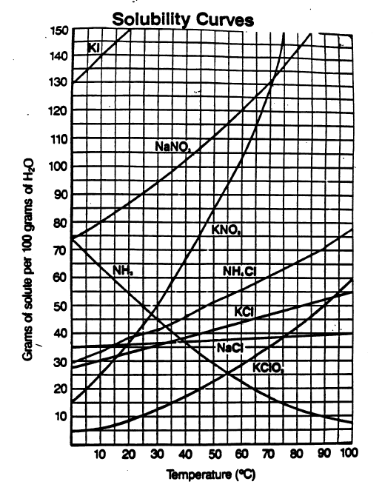

Interpreting Solubility Curves
1. Which substance does not appear to increase greatly in solubility as the temperature is increased?
2. Which substance appears to decrease in solubility as the temperature is increased?
3. Which substance appears to increase most in solubility as the temperature is increased?
4. Which substance is most soluble at O. degrees Celsius?
5. Which substance is least soluble at O. degrees Celsius?
6. Which two substances have the same solubility at 71. degrees Celsius?
7. What is the most KN0₃ that can be dissolved at 70. degrees Celsius?
8. What is the most NH₄Cl that can be dissolved at 70. degrees Celsius?
9. At 70. degrees Celsius which substance, KN0₃ or NH₄Cl, can form the more concentrated solution?
10. At what temperature would you need 100. g of water to dissolve 70. g of NH₄Cl?
11. At what temperature would you need 100. g of water to dissolve 70. g of KN0₃?
12. A solution that holds 40. g of KCl at 10. degrees Celsius can be described as a _____________ solution.
13. A solution that holds 90. g of NaNO₃ at 55. degrees Celsius can be described as a ______________ solution.

EXPLAIN: (20 min.)
Upon completion of problems, allow the students the opportunity to explain how they derived their answers. This can be done by conducting a jigsaw activity or by allowing students to go to the board/overhead.

EVALUATE:
Sample Assessment Questions:
Unit | Goal/RBT Tag | Questions
1 | 2.04  C3  C3 | 1. Identify the substance that is a liquid at -100 ^{O}C.  a. hydrogen  b. hydrogen chloride  c. hydrogen sulfide  d. nitrogen  2. What volume will 50.0g of iron occupy?  a. 6.36 cm³  b. 22.5 cm³  c. 157 cm³  d. 393 cm³
1 | 2.08  B4  B4 | Refer to the phase diagram below to answer the following questions:  1. Which point on the diagram represents the point in which solid, liquid, and gas exist in equilibrium with one another?  a. A  b. B  c. C  d. D  2. Which point on the diagram represents the point where sublimation is occurring?  a. A  b. B  c. C  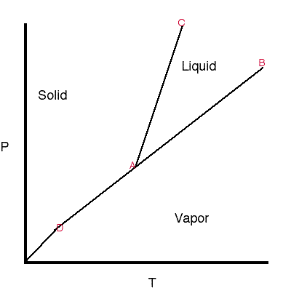  d. D  diagram  http://www.cartage.org.lb/en/themes/Sciences/Chemistry/Miscellenous/Helpfile/LiquidandSolid/PhaseDiagrams/phase2.gif

