I. Grade Level/Unit Number: 9-12 Unit 2

II: Unit Title: Atomic Theory and Structure

III. Unit Length: 5 days (on a 90 min. per day block schedule)

- Major Learning Outcomes:

Students should be able to:
Atomic Theory

- Describe the composition of the atom and the experiments that led to that knowledge
- Describe how Rutherford predicted the nucleus
- Understand the inverse relationship between wavelength and frequency, and the direct relationship between energy and frequency
- Analyze diagrams related to the Bohr model of the hydrogen atom in terms of allowed, discrete energy levels in the emission spectrum
- Describe the electron cloud of the atom in terms of a probability model

Atomic Structure
- Characterize the protons, neutrons, electrons: location, relative charge, relative mass (p=1, n=1, e=1/2000).
- Use symbols: A= mass number, Z=atomic number
- Use notation for writing isotope symbols: or U-235
- Identify isotope using mass number and atomic number and relate to number of protons, neutrons and electrons
- Have a conceptual awareness of the nature of average atomic mass. (Relative abundance of each isotope determines the average- no calculations)

- Content Objectives Includes (with RBT Tags):

Objective Number | Objective | RBT Tag
2.01 | Analyze the historical development of the current atomic theory.  - Early contributions: Democritus and Dalton.  - The discovery of the electron: Thomson and Millikan.  - The discovery of the nucleus, proton and neutron: Rutherford and Chadwick.  - The Bohr model.  - The quantum mechanical model. | B4
2.02 | Examine the nature of atomic structure  - Subatomic particles: protons, neutrons, and electrons.  - Mass number.  - Atomic number.  - Isotopes. | B4
2.02-1 H | Analyze (calculate) average atomic mass from relative abundance and actual isotopic mass.

- English Language Development Objectives (ELD) Included:
NC English Language Proficiency (ELP) Standard 4 (2008) for Limited English Proficiency Students (LEP)- English Language learners communicate information, ideas, and concepts necessary for academic success in the content area of science.

Suggestions for modified instruction and scaffolding for LEP students and/or students who need additional support are embedded in the unit plan and/or are added at the end of the corresponding section of the lessons. The amount of scaffolding needed will depend on the level of English proficiency of each LEP student. Therefore, novice level students will need more support with the language needed to understand and demonstrate the acquisition of concepts than intermediate or advanced students.

- Materials/Equipment Needed

Activity | Materials
Black Box | small, rectangular black boxes  marbles (magnetic, if available) or steel balls  magnets (if available)
Atomic Theory Timeline | Continuous feed computer paper (or copy paper and tape)  markers  colored pencils  glue  pictures of scientists where available
Candium Lab (honors activity) | Balances  Reeses pieces  M & M’s  Skittles

- Detailed Content Description:
Please see the detailed content description for each objective in the chemistry support document. The link to this downloadable document is in the Chemistry Standard Course of Study at:

http://www.ncpublicschools.org/curriculum/science/scos/2004/24chemistry

- Unit Notes:

This unit is focused on the development of the theory of the atom, the structure of the atom and nuclear decay. Students will learn about the historical development of the atom beginning with early contributions through the current atomic theory. Students will examine the structure of the atom and analyze nuclear energy as it relates to the atom.

In each unit, Goal 1 objectives which relate to the process of scientific investigation are included. In each of the units, students will be practicing the processes of science: observing, hypothesizing, collecting data, analyzing, and concluding. The Goal 1 Objectives are as follows:

COMPETENCY GOAL 1: The learner will develop abilities necessary to do and understand scientific inquiry.
1.01 Design, conduct and analyze investigations to answer questions related to chemistry.  - Identify questions and suggest hypotheses.  - Identify variables.  - Use a control when appropriate.  - Select and use appropriate measurement tools.  - Collect and organize data in tables, charts and graphs.  - Analyze and interpret data.  - Explain observations.  - Make inferences and predictions.  - Explain the relationship between evidence and explanation.  - Identify how scientists share findings. | This goal and these objectives are an integral part of each of the other goals. In order to measure and investigate scientific phenomena, students must be given the opportunity to design and conduct their own investigations in a safe laboratory. The students should use questions and models to formulate the relationship identified in their investigations and then report and share those finding with others  Students will be able to:  - Identify questions and suggest hypotheses.  - Identify variables.  - Use a control when appropriate.  - Select and use appropriate measurement tools.  - Collect and organize data in tables, charts and graphs.  - Analyze and interpret data.  - Explain observations.  - Make inferences and predictions.  - Use questions and models to determine the relationships between variables in investigations.  - Identify how scientists share findings.

If a teacher follows this curriculum (s)he will have addressed the goals and objectives of the SCOS. However, teachers may want to substitute other activities that teach the same concept. The unit length has extra time built in for quizzes, going over homework, additional practice depending on the nature of the class, and assessment. Teachers should utilize the textbook as a resource by assigning homework each day and providing additional guided and independent practice.

Reference Tables:
The North Carolina Chemistry Reference Tables were developed to provide essential information that should be used on a regular basis by students, therefore eliminating the need for memorization. It is suggested that a copy be provided to each student on the first day of instruction. A copy of the reference tables can be downloaded at the following URL:

http://www.ncpublicschools.org/docs/curriculum/science/scos/2004/chemistry/referencetables.pdf

Essential Questions:
Essential questions for this unit are embedded within the unit. Essential questions are those questions that lead to student understanding. Students should be able to answer these questions at the end of an activity. Teachers are advised to put these questions up in a prominent place in the classroom. The questions can be answered in a journal format as a closure.

Safety: Students should wear chemical splash goggles during any lab activity involving chemicals. This includes household substances. It is extremely important for the safety and success of your students that you do ALL activities and labs prior to assigning them to students. At the beginning of each lab, the teacher should address any specific safety concerns relating to the activity.

Computer Based Activities:
Several of the recommended activities are computer based and require students to visit various internet sites and view animations of various biological processes. These animations require various players and plug-ins which may or may not already be installed on your computers. Additionally some districts have firewalls that block downloading these types of files. Before assigning these activities to students it is essential for the teacher to try them on the computers that the students will use and to consult with the technology or media specialist if there are issues. These animations also have sound. Teachers may wish to provide headphones if possible.

- Global Content: Aligned with 21st Skills:
One of the goals of the unit plans is to provide strategies that will enable educators to develop the 21st Century skills for their students. As much as students need to master the NCSOS goals and objectives, they need to master the skills that develop problem solving strategies, as well as the creativity and innovative thinking skills that have become critical in today’s increasingly interconnected workforce and society. The Partnership for 21st Century Skills website is provided below for more information about the skills and resources related to the 21st Century classroom.

http://www.21stcenturyskills.org/index.php?option=com_content&task=view&id=27&Itemid=120

NC SCS Chemistry | 21st Century Skills | Activity
 | Communication Skills
1.01 - 1.03, 2.01, 2.02 | Conveying thought or opinions effectively | - Black Box  - Isotope Problems  - What is an Atom?  - Candium Lab
1.01 - 1.03 | When presenting information, distinguishing between relevant and irrelevant information
1.01 & 1.03, 2.01, 2.02, | Explaining a concept to others | - Black Box  - Atomic Theory KWL  - Isotope Problems  - What is an Atom?  - Candium Lab
 | Interviewing others or being interviewed
 | Computer Knowledge
1.01 – 1.03 | Using word-processing and database programs
1.01 – 1.03 | Developing visual aides for presentations
1.01 – 1.03 | Using a computer for communication
2.01, 2.02 | Learning new software programs | - SAS Activities
 | Employability Skills
1.01 - 1.03, 2.01, 2.02 | Assuming responsibility for own learning | - Black Box  - What is an Atom?
- - 1.03,  2.01, 2.02 | Persisting until job is completed | - All activities
- - 1.03  2.02 | Working independently | - Isotope Problems
 | Developing career interest/goals
1.01 – 1.03 | Responding to criticism or questions
 | Information-retrieval Skills
2.01 | Searching for information via the computer | - Atomic Theory Time-line
 | Searching for print information
 | Searching for information using community members
 | Language Skills - Reading
2.01, 2.02 | Following written directions | - Most of the activities can be presented as opportunities for students to follow written directions. The teacher will have to work with most students to develop this skill over time. The following activities are well suited to developing skills in following directions:  - Black Box  - Atomic Theory KWL  - Isotope Problems  - What is an Atom?  - Candium Lab
2.01 | Identifying cause and effect relationships | - Black Box
2.01 | Summarizing main points after reading | - Atomic Theory KWL
2.01 | Locating and choosing appropriate reference materials | - Atomic Theory Time-line
 | Reading for personal learning
 | Language Skill - Writing
 | Using language accurately
1.01 – 1.03,  2.01, 2.02-1 H | Organizing and relating ideas when writing | - Black Box  - Candium
- – 1.03  2.01, 2.02 | Proofing and Editing | - All activities
 | Synthesizing information from several sources
 | Documenting sources
 | Developing an outline
1.03 | Writing to persuade or justify a position
 | Creating memos, letters, other forms of correspondence
 | Teamwork
1.01 – 1.03 | Taking initiative
- – 1.03,  2.01, 2.02, 2.02-1 H | Working on a team | - Black Box  - Atomic Theory KWL  - What is an Atom?  - Candium Lab
 | Thinking/Problem-Solving Skills
 | Identifying key problems or questions
- – 1.03,  2.01, 2.02, 2.02-1 H | Evaluating results | - Black Box  - Atomic Theory KWL  - What is an Atom?  - Candium Lab
 | Developing strategies to address problems
2.01 | Developing an action plan or timeline | - Atomic Theory KWL

ENGAGE: (30 min.)

The black box activity is an introductory activity for atomic theory. It helps students grasp the idea of developing models without being able to see with their eyes. The students act as scientists in developing a model of the shapes that exist inside of the black box by allowing a steel ball or marble to roll around the shapes. Teacher notes for creating boxes are included with the activity. This needs to be developed ahead of time. Creating the boxes takes time but they can be used over and over each semester.

The following is a web-based black box activity that can be used as an alternative if your students have internet access.

http://sv.berkeley.edu/showcase/pages/laser.html

Essential Question:
Why do scientists use models in chemistry?

Language (ELP) Objective for LEP Students:
- Student will verbalize how he or she would explain the Black Box activity to another student.
- Student will write a paragraph explaining how this activity helped him or her understand the nature of how scientists conduct experiments. Example: Scientists use can use models like the Black Box in order to understand……

Black Box

Teacher Notes:

Each student receives one small, somewhat flat, rectangular black box. They are similar in size to the old 3½ inch computer diskette holders, only my boxes are rectangular instead of square.

There are 4 variations within the black boxes. Label each box A, B, C, or D depending on the layout within the box. Within each box is one or more pieces of corrugated cardboard, about as thick as the box. You may need to paste 2-3 layers together to get the right thickness. You will also need one steel ball or a magnetic marble for each box. Below are the arrangements I will use:

C

A

B

Represents steel ball or marble

D

Boxes will be taped shut, Use lots of tape. The impulse to look inside is irresistible! It’s up to you in the end whether to open the boxes or not. In reality, scientists seldom get a chance to “open the box” and must instead live with the uncertainty of their models. However, new technologies and/or experiments usually reinforce the model over time. The heliocentric model of the solar system, for example, isn’t likely going to change in spite of the fact that we have never directly observed the arrangement of the planets from some vantage point in outer space.

I will have students work groups of 3. I will give one box to each group students. A group will work together on one of the arrangements: A, B, C, or D. After approximately 10 minutes, the A’s will get together, compare notes, and revise models based on collaboration.

This activity is adapted from the FOSS Models & Designs Module.
http://www.middleschoolscience.org/blog/2004/09/mental-model-details-analysis.html

As a conclusion to this activity, have students reflect on the processes they went through to construct a model without making direct measurements. This will provide transition as you set-up the next activity (The Atomic Theory Timeline).

Name ___________________________________________________ Class _____________ Date __________

Lab # _______
Black Box: Mental Models

Follow the procedures outlined below. At the end of this activity you will write a report describing the purpose, procedure and conclusions. You will work in groups, but each member of the group must complete all the work and retain this lab report for your binder.

1. In the box below, draw a diagram that shows what you think it looks like inside your black box.

This diagram is your “mental model” of what the inside of the box looks like. It is a mental model because you cannot actually see what’s in the box directly, and you are instead using non-visual observations to create a visual representation.

2. Describe how you arrived at your model. Which senses did you use? What evidence did you use?

3. In this room there are other scientists who are also trying to make mental models of the same black box that you are observing. If 10 people are creating mental models of the same object, should the mental models match, or is it acceptable to have 10 different mental models of the same object? Explain.

You will now consult with those other scientists and try to reach a consensus about your mental model. You will try to convince your colleagues that your model is correct using evidence and logic. It is possible that all of you will eventually make changes to your model, or it is also possible that you will all be persuaded that one of the existing models is correct.

4. In the box below, draw your revised model of the black box.

5. How did you and your colleagues arrive at the revised model? What evidence was presented, how did you change your model and why?

6. You and your colleagues will make a presentation to the rest of the class and try to convince them that your model is correct. Decide who will present your group’s arguments and pick the most important observations that you think will convince your audience that your model is correct. Pick a recorder who will record any objections, questions, or suggestions that come from the larger group. You may want to use this feedback later to make revise your model even further. Sketch the final version of your model below.

EXPLORE: (60 min.)

The Atomic Theory Time-line will allow students to explore the discoveries that led to the contributions to the theory of the atom. Provide continuous feed computer paper (or copy paper and tape), markers, colored pencils, glue, and pictures of scientists where available.

The following is a web-based research activity that could be used as an alternative. Keep in mind that the scientists provided in this activity include many not in the standard course of study. You may wish to modify the names in the activity if you choose this alternative. You will have to register with SAS in order for your students to have a login. Contact your technology support for help with obtaining this information. The name of the activity is Evolution of Atomic Theory and the Quick Launch number is 988.

http://www.sasinschool.com/ProductEntrance/Login/login.jsp

Essential Questions:
- How would you describe Rutherford’s experiment?
- How would you describe the contributions made by scientists to develop the atomic theory?

Language (ELP) Objectives for LEP Students:
- Have each student choose one of the basic concepts of the atomic theory from the concept checklist at the beginning of this lesson. In pairs or small groups, explain their concept orally to another student.
- Describe orally or write a paragraph explaining how student constructed timeline. Example: First I (We)…., second I (we)…because...Finally I (we)…….
- Discuss orally or written in a paragraph the contribution of one of the featured scientists from the timeline. Student may include the following:
1. Name
2. Birth/death
3. Research/Contribution
4. Other interesting fact

In groups, students research scientists (using text) that contributed to the theory of the atom. Students create a time-line in order by scientist’s contribution. Students should include dates, person responsible for the theory or model and basic aspects of the theory/model that led to their contribution. Students should include diagrams and drawings where applicable. The teacher should provide students with the range of pages in their text that discuss the Atomic Theory. The teacher may wish to provide names of scientists for a shorter activity. (Democritus, Dalton, Thomson, Millikan, Rutherford, Chadwick, Bohr, Quantum Mechanical Model). The internet could be used for research purposes. The teacher should provide names if using the internet to keep the activity guided in the right direction.

EXPLAIN, ELABORATE, AND EVALUATE: (30 min.)
The Atomic Theory KWL is a follow-up activity for the timeline to make sure that students understand what they researched and to check for misconceptions.

Essential Question:
How do the early models of the atom lead to the current atomic theory?
Language (ELP) Objectives for LEP Students:
- Have students orally share information from their KWL charts in pairs, small groups, and or in the class as a whole.
- Construct a concept map from class notes and information from what they learned from the “L” section of their KWL charts. A concept map is a visual representation of information. This can include graphic organizers, flow charts, or diagrams which relate concepts together.

KWL (Know – Want to Know – Learned) - Have students complete the Know and Want to Know columns of a chart – share ideas with class or in small groups
- KNOW (EXPLAIN) – What do you know after completing your timeline for atomic theory?
  - WANT (ELABORATE) – What do you want or need to know about atomic theory? (In other words, what do you not understand about atomic theory?)
This activity should provide an opportunity for a class discussion where the teacher can instruct students on the historical contributions to atomic theory (see goal 2.01) and check for misconceptions. There are following websites can be used during the class discussion:
Rutherford
http://www.mhhe.com/physsci/chemistry/essentialchemistry/flash/ruther14.swf
http://www.dlt.ncssm.edu/TIGER/diagrams/structure/GoldFoilExperiment.jpg
http://www.dlt.ncssm.edu/TIGER/diagrams/structure/GoldDescription500x475.gif
Thomson
http://www.dlt.ncssm.edu/TIGER/diagrams/structure/CRT-Plates640.gif
http://www.dlt.ncssm.edu/TIGER/diagrams/structure/CRT-Magnet640.gif
Millikan
http://www.dlt.ncssm.edu/TIGER/Flash/structure/OilDrop.html

- (EVALUATE) Students should complete the learned column of the KWL.

EXPLORE: (60 min.)

This (What Is an Atom?) is an inquiry activity in which students independently discover the meanings of atomic number, mass number and how to determine the # of protons, neutrons and electrons in atoms and ions. Students should do this activity with little teacher instruction and before the lesson that specifically defines atomic mass and mass number.

Essential Question:
How would you describe subatomic particles?

What Is an Atom?

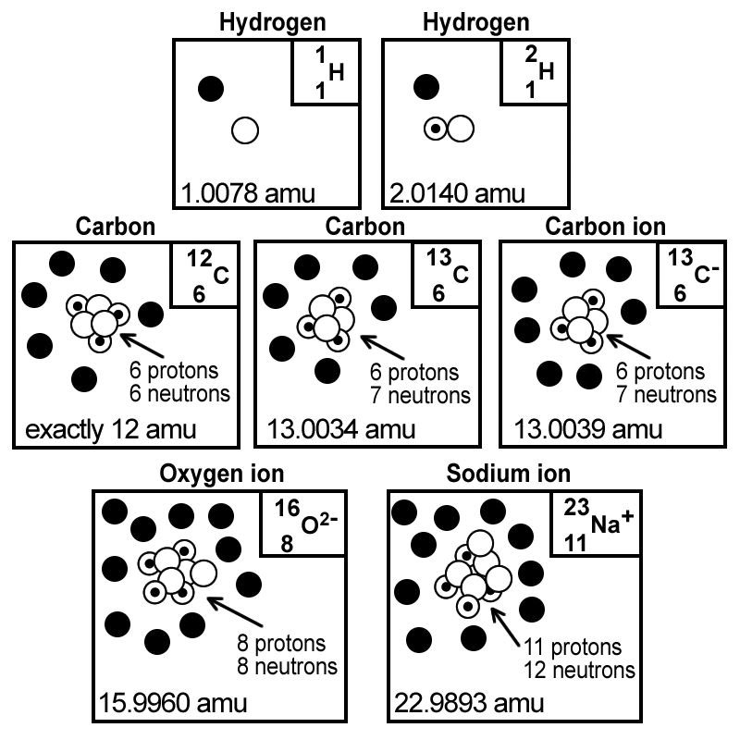
Data collected from selected atoms.
 | Electron (-)  Proton (+)  Neutron (neutral)
A is the mass number
Z the atomic number
The nucleus of an atom contains the protons and the neutrons.
¹H and ²H are isotopes of hydrogen.
¹²C and ¹³C are isotopes of carbon.
An ion is a charged particle, O²⁻ and Na⁺ are ions.
You can’t see all the neutron and protons in the nucleus in the diagrams.

Chemists identify isotopes by using a mass spectrometer. The separation is possible because each isotope has a different mass. Lighter masses will bend more as they pass through the magnet field.
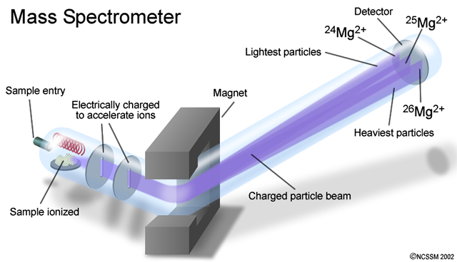

Critical Thinking Questions

- How many protons are found in ¹²C?_______ ¹³C? ____¹³C⁻ ?____

- How many neutrons are founds in ¹²C?_____ ¹³C? ____¹³C⁻ ?____

- How many electrons are found in ¹²C?____ ¹³C?_____ ¹³C⁻ ?____

- Based on the data presented above,
  - What do all carbon atoms (and ions) have in common?

  - What do all hydrogen atoms (and ions) have in common?

- What is the significance of the atomic number, Z? Where will you find it on the periodic table?

- Look at a periodic table, what do all nickel (Ni) atoms have in common?

- How is the mass number, A, determined?

- What structural feature is different in isotopes of a particular element?
- What feature distinguishes a neutral atom from an ion?

10. Where is most of the mass of an atom, within the nucleus or outside of the nucleus? Explain your reasoning.

11. Complete the chart below:
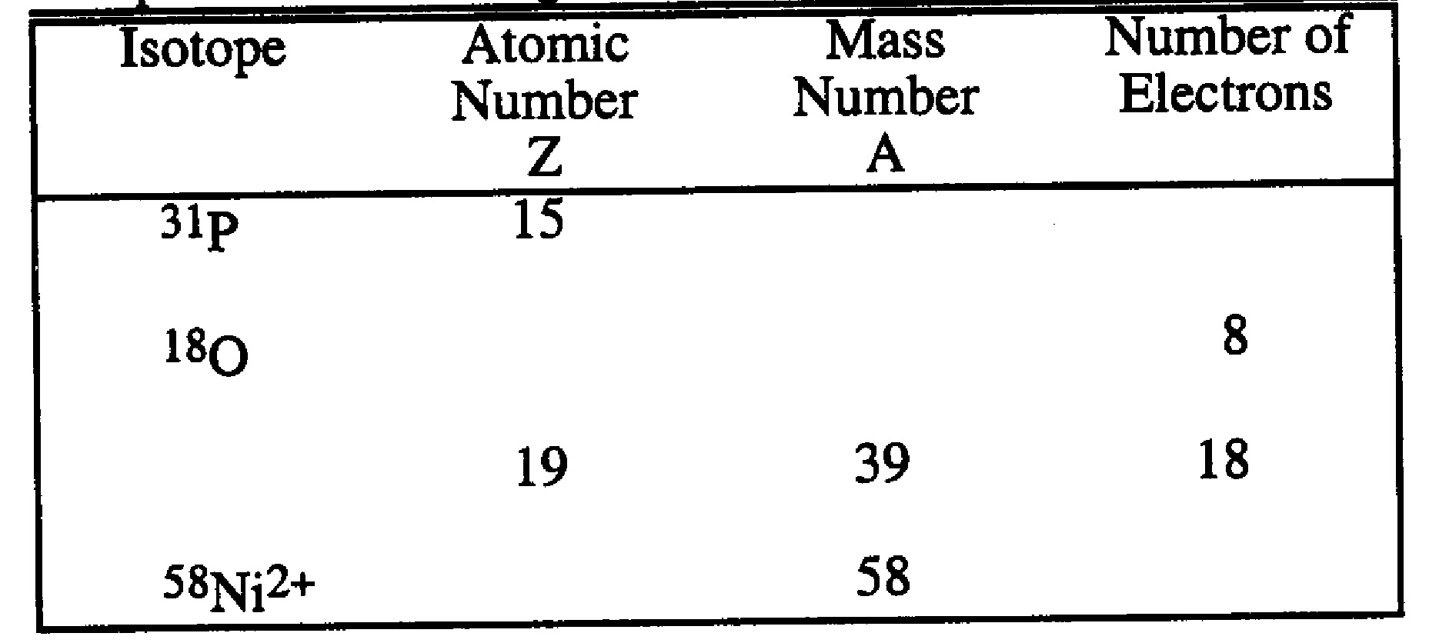

12. What is the mass (in amu) of
a. one ¹H atom? ______________
b. one ¹²C atom? _____________

13. Define mass number

14. Define atomic number.

15. How many electrons, protons, and neutrons are found in each of the following?
Atom or ion | Electrons | Protons | neutrons
²⁴Mg
²³Na⁺
³⁵Cl
³⁵Cl⁻
⁵⁶Fe³⁺
¹⁵N
¹⁶O²⁻
²⁷Al³⁺

16. Summary of Activity: Describe an atom

What is an Atom? (KEY)

Critical Thinking Questions

- How many protons are found in ¹²C? 6 ¹³C? 6 ¹³C⁻ ? 6

- How many neutrons are founds in ¹²C? 6 ¹³C? 7 ¹³C⁻ ? 7

- How many electrons are found in ¹²C? 6 ¹³C? 6 ¹³C⁻ ? 7

- Based on the data presented above,
  - What do all carbon atoms (and ions) have in common?
Same # of protons

  - What do all hydrogen atoms (and ions) have in common?

Same # of protons
- What is the significance of the atomic number, Z? Where will you find it on the periodic table?
Z = # of protons; Whole # with each symbol

- Look at a periodic table, what do all nickel (Ni) atoms have in common?
28 protons

- How is the mass number, A, determined?
protons and neutrons

- What structural feature is different in isotopes of a particular element?

Different # of neutrons

- What feature distinguishes a neutral atom from an ion?

Different # of electrons

- Where is most of the mass of an atom, within the nucleus or outside of the nucleus? Explain your reasoning.
Within the nucleus; mass # = protons + neutrons, electrons are not considered when calculating mass #

- Complete the chart below:

Isotope | Atomic Number  Z | Mass Number  A | Number of Electrons
³¹P | 15 | 31 | 15
¹⁸O | 8 | 18 | 8
³⁹K⁺¹ | 19 | 39 | 18
⁵⁸Ni²⁺ | 28 | 58 | 26

12. What is the mass (in amu) of
a. one ¹H atom? 1 amu
b. one ¹²C atom? 12 amu

13. Define mass number. protons + neutrons

14. Define atomic number. # of protons

15. How many electrons, protons, and neutrons are found in each of the following?
Atom or ion | Electrons | Protons | Neutrons
²⁴Mg | 12 | 12 | 12
²³Na⁺ | 10 | 11 | 12
³⁵Cl | 17 | 17 | 18
³⁵Cl⁻ | 18 | 17 | 18
⁵⁶Fe³⁺ | 23 | 26 | 30
¹⁵N | 7 | 7 | 8
¹⁶O²⁻ | 10 | 8 | 8
²⁷Al³⁺ | 10 | 13 | 14

EXPLAIN: (15 min.)

Following The Atom Activity, the teacher should provide a class discussion to allow students to explain the concepts relating to the structure of the atom. The teacher should refer to goal 2.02 for specific content.

The website below provides an activity for students relating to atomic structure. It could be used as a tutorial for students who need extra help:
http://www.sasinschool.com/ProductEntrance/Login/login.jsp
The name of the activity is Atomic Structure and the Quick Launch number is 1197. You will have to register with SAS in order for your students to have a login. Contact your technology support for help with obtaining this information.

Essential Question:
What is the relationship between an isotope and the mass of an atom?

ELABORATE: (30 min.)
This activity will allow for elaboration and provide guided or independent practice following the discussion.

Essential Question:
What is the relationship between an isotope and the mass of an atom?

Isotope Handout

Sample Problems: Determine the number of protons, neutrons and electrons in the following atoms.

1. ³⁵₁₇Cl p _____ n _____ e______

2. ²³⁸₉₂U p _____ n _____ e______

3. ³²₁₆S p _____ n _____ e______

4. ²⁰⁶₈₂Pb p _____ n _____ e______

Fill in the blanks in the table below.

Symbol | Atomic Number | Number of protons | Number of neutrons | Number of electrons | Mass number
Be |  |  | 5
P⁻³ |  |  |  |  | 31
U |  |  | 146
Ca⁺² |  |  |  |  | 40

1. Complete the following table:
Isotope | Atomic # | Mass # | # protons | # neutrons | # electrons
³⁵₁₇Cl⁻¹

⁶⁵₃₀Zn⁺²

Ca⁺² |  |  |  | 20

2. Complete the following table:
Isotope | Atomic number | Mass number | # of protons | # of neutrons | # of electrons
³²S

N⁻³ |  | 15
⁴⁰Ca⁺²

Zn |  |  |  | 35
Zn⁺² |  |  |  | 35
Uraninum-238

¹⁹F⁻¹

Na⁺¹ |  | 23

EXPLORE (honors): (45 minutes)

This Candium activity will allow honors students to EXPLORE average atomic mass. This activity will meet the honors objective for calculating the average atomic mass. The teacher needs to purchase a large bag of each type of candy ahead of time (M&M’s, skittles, Reeses pieces). All the candy must be mixed ahead of time to create Candium. Dixie cups can be used to hold the samples. Students should return the samples upon completion and the teacher should store the candy in an air tight container for the next time. The teacher can buy additional candy to share with the students after the lab is completed so they might enjoy this wonderful new discovery!!!!!

Essential Question:
What do you need to know to calculate the average atomic mass of an element?

Candium Lab Activity

Objective: The objective of this lab is to determine the average atomic mass of a newly discovered element called “Candium”.

Materials:
Balance
Sample of candium
Calculator
Pencil and paper

Procedure: Obtain a sample of candium from the teacher. Separate the three isotopes (Skittles, M&M’s, and Reese’s Pieces) and measure the mass of each isotope. Count the numbers of each isotope. Record your data.

Analysis: Using this data, make the following calculations. Show your work and make sure to include units. Label each calculation according to the isotope.

- Calculate the average mass of each isotope by dividing its total mass by the number of particles of that isotope. (3 calculations)

- Calculate the percent abundance of each isotope by dividing its number of particles by the total number of particles and multiplying by 100. (3 calculations)

- Calculate the relative abundance of each isotope by dividing the percent abundance from #2 by 100. (3 calculations)

- Calculate the relative mass of each isotope by multiplying its relative
abundance from #3 by its average mass (#1). (3 calculations)

- Calculate the average atomic mass of all candium particles by adding the relative masses (#4). This is the average atomic mass of this strange new element.

- Now, explain, in your own words, the difference between percent abundance and relative abundance.

- Compare the average atomic mass that you calculated with that
calculated by your neighbor. Explain why the difference would be
smaller if larger samples were used.

EXPLAIN: (15 min.)
Upon completion of the activity, allow the students the opportunity the concept of average atomic mass and how they derived their answers.

EVALUATE:
Sample Assessment Questions:
Unit | Goal/ RBT Tag | Questions
2 | 2.01  B4  B4 | 1. Which of the following behaviors allows one to distinguish between Rutherford’s and Thompson’s atomic model?  a. Atoms are electrically neutral.  b. Atoms are mostly empty space.  c. Atoms contain neutrons.  d. Atoms are indivisible.  2. Identify which part of Dalton’s Atomic Theory has been proven incorrect?  a. Matter is made up of atoms.  b. Atoms are indivisible.  c. Atoms can be rearranged to form new compounds.  d. Atoms cannot be created or destroyed.
 | 2.02  B4  B4 | 1. Identify which of the following statements is correct concerning an atom?  a. Its subatomic particles carry no electrical charges.  b. The number of protons equals the number of neutrons.  c. The number of neutrons equals the number of electrons.  d. The number of protons equals the number of electrons.  2. Compare the numbers of neutrons in a Carbon-12 and Carbon-14?  a. C-14 has 2 more neutrons than C-12.  b. C-14 has the same number of neutrons as C-12.  c. C-12 has 2 more neutrons than C-14.  d. Cannot be determined from the information given.

EVALUATE: (45 minutes)

Below are sample test items obtained from the WIZARD test bank developed by eduware™ that can be used to allow students to assess their understanding and abilities and allow the teacher to evaluate the students understanding of key concepts and skill development for this unit.

