I. Grade Level/Unit Number: 9-12 Unit 3

II: Unit Title: Electromagnetic Spectrum and Quantum Theory

III. Unit Length: 5 days (on a 90 min. per day block schedule)

- Major Learning Outcomes:

Students should be able to:
- Analyze diagrams related to the Bohr model of the hydrogen atom and indicate that:
  - an electron circles the nucleus only in fixed energy ranges called orbits (energy levels)
  - an electron can move from one orbit to another by either gaining or losing energy
  - the lowest energy level is that closest to the nucleus
- Understand that energy exist in discrete units called quanta (photons)
- Describe an “excited” atom above its ground state by the addition of energy, resulting in the electron moving to a higher energy level
- Know that when the electron returns to its ground state, energy is released as electromagnetic radiation
- Recognize the historical contribution of the Bohr model to our modern atomic theory and realize the limitations of the model
- Describe the wave/particle duality of electrons
- Articulate that this electromagnetic radiation is given off as a photon(s). This photon represents the physical difference between ground state and excited state.
- Use the “Bohr Model for Hydrogen Atom” and “Electromagnetic Spectrum” diagrams from the Reference Tables to relate color, frequency, and wavelength of the light emitted to the energy of the photon.
- Understand the inverse relationship between wavelength and frequency, and the direct relationship between energy and frequency.
- Write electron configurations, including noble gas abbreviations (no exceptions to the general rules). Included here are extended arrangements showing electrons in orbitals.
- Identify s, p, d, and f blocks on Periodic Table.
- Identify an element based on its electron configuration. (Students should be able to identify elements which follow the general rules, not necessarily those which are exceptions.)
- Determine the number of valence electrons from electron configurations.
- Predict the number of electrons lost or gained and the oxidation number based on the electron configuration of an atom.

- Content Objectives Includes (with RBT Tags):

Objective Number | Objective | RBT Tag
4.01 | Analyze the Bohr model in terms of electron energies in the hydrogen atom.  - The spectrum of electromagnetic energy.  - Emission and absorption of electromagnetic energy as electrons change energy levels. | B4
3.01 | Analyze periodic trends in chemical properties and use the periodic table to predict properties of elements.  - Electron configuration and energy levels. | C4
2.01-1 H | Apply quantum numbers to electron configurations.

- English Language Development Objectives (ELD) Included:
NC English Language Proficiency (ELP) Standard 4 (2008) for Limited English Proficiency Students (LEP)- English Language learners communicate information, ideas, and concepts necessary for academic success in the content area of science.

Suggestions for modified instruction and scaffolding for LEP students and/or students who need additional support are embedded in the unit plan and/or are added at the end of the corresponding section of the lessons. The amount of scaffolding needed will depend on the level of English proficiency of each LEP student. Therefore, novice level students will need more support with the language needed to understand and demonstrate the acquisition of concepts than intermediate or advanced students.

- Materials/Equipment Needed

Activity | Materials
Identification of Metals: Flame Tests | Q-tips (non-plastic) swabs soaked in each of the following solutions:  - Sodium nitrate, NaNO₃  - Potassium nitrate, KNO₃  - Calcium nitrate, Ca(NO₃)₂  - Strontium nitrate, Sr(NO₃)₂  - Lithium nitrate, LiNO₃  - Copper (II) nitrate, Cu(NO₃)₂  - Barium nitrate, Ba(NO₃)₂  Meker/Bunsen burner  Cobalt-blue glass  Safety goggles  Crucible tongs  Beaker of water

- Detailed Content Description:
Please see the detailed content description for each objective in the chemistry support document. The link to this downloadable document is in the Chemistry Standard Course of Study at:

http://www.ncpublicschools.org/curriculum/science/scos/2004/24chemistry

- Unit Notes:

This unit is focused on the understanding the Bohr model of the atom and the development of the quantum theory. Students will learn about the Bohr model, as it relates to the hydrogen atom. They will recognize the historical contribution that this model gave to our modern theory of the structure of the atom.

In each unit, Goal 1 objectives which relate to the process of scientific investigation are included. In each of the units, students will be practicing the processes of science: observing, hypothesizing, collecting data, analyzing, and concluding. The Goal 1 Objectives are as follows:

COMPETENCY GOAL 1: The learner will develop abilities necessary to do and understand scientific inquiry.
1.01 Design, conduct and analyze investigations to answer questions related to chemistry.  - Identify questions and suggest hypotheses.  - Identify variables.  - Use a control when appropriate.  - Select and use appropriate measurement tools.  - Collect and organize data in tables, charts and graphs.  - Analyze and interpret data.  - Explain observations.  - Make inferences and predictions.  - Explain the relationship between evidence and explanation.  - Identify how scientists share findings. | This goal and these objectives are an integral part of each of the other goals. In order to measure and investigate scientific phenomena, students must be given the opportunity to design and conduct their own investigations in a safe laboratory. The students should use questions and models to formulate the relationship identified in their investigations and then report and share those finding with others  Students will be able to:  - Identify questions and suggest hypotheses.  - Identify variables.  - Use a control when appropriate.  - Select and use appropriate measurement tools.  - Collect and organize data in tables, charts and graphs.  - Analyze and interpret data.  - Explain observations.  - Make inferences and predictions.  - Use questions and models to determine the relationships between variables in investigations.  - Identify how scientists share findings.

If a teacher follows this curriculum (s)he will have addressed the goals and objectives of the SCOS. However, teachers may want to substitute other activities that teach the same concept. The unit length has extra time built in for quizzes, going over homework, additional practice depending on the nature of the class, and assessment. Teachers should utilize the textbook as a resource by assigning homework each day and providing additional guided and independent practice.

Reference Tables:
The North Carolina Chemistry Reference Tables were developed to provide essential information that should be used on a regular basis by students, therefore eliminating the need for memorization. It is suggested that a copy be provided to each student on the first day of instruction. A copy of the reference tables can be downloaded at the following URL:

http://www.ncpublicschools.org/docs/curriculum/science/scos/2004/chemistry/referencetables.pdf

Essential Questions:
Essential questions for this unit are embedded within the unit. Essential questions are those questions that lead to student understanding. Students should be able to answer these questions at the end of an activity. Teachers are advised to put these questions up in a prominent place in the classroom. The questions can be answered in a journal format as a closure.

Safety: Students should wear chemical splash goggles during any lab activity involving chemicals. This includes household substances. It is extremely important for the safety and success of your students that you do ALL activities and labs prior to assigning them to students. At the beginning of each lab, the teacher should address any specific safety concerns relating to the activity.

Computer Based Activities:
Several of the recommended activities are computer based and require students to visit various internet sites and view animations of various biological processes. These animations require various players and plug-ins which may or may not already be installed on your computers. Additionally some districts have firewalls that block downloading these types of files. Before assigning these activities to students it is essential for the teacher to try them on the computers that the students will use and to consult with the technology or media specialist if there are issues. These animations also have sound. Teachers may wish to provide headphones if possible.

- Global Content: Aligned with 21st Skills
One of the goals of the unit plans is to provide strategies that will enable educators to develop the 21st Century skills for their students. As much as students need to master the NCSOS goals and objectives, they need to master the skills that develop problem solving strategies, as well as the creativity and innovative thinking skills that have become critical in today’s increasingly interconnected workforce and society. The Partnership for 21st Century Skills website is provided below for more information about the skills and resources related to the 21st Century classroom.

http://www.21stcenturyskills.org/index.php?option=com_content&task=view&id=27&Itemid=120

NC SCS Chemistry | 21st Century Skills | Activity
 | Communication Skills
1.01 - 1.03, 3.01 & 4.01 | Conveying thought or opinions effectively | - Identification of Metals  - Hog Hilton
1.01 - 1.03 | When presenting information, distinguishing between relevant and irrelevant information
1.01 & 1.03, 3.01 & 4.01 | Explaining a concept to others | - Identification of Metals  - Hog Hilton  - Looking for Connections  - Bohr Model and Electromagnetic Spectrum Practice
 | Interviewing others or being interviewed
 | Computer Knowledge
1.01 – 1.03 | Using word-processing and database programs
1.01 – 1.03 | Developing visual aides for presentations
1.01 – 1.03 | Using a computer for communication
 | Learning new software programs
 | Employability Skills
- - 1.03,  3.01 & 4.01 | Assuming responsibility for own learning | - Identification of Metals  - Hog Hilton  - Looking for Connections
1.01 - 1.03, 3.01 & 4.01 | Persisting until job is completed | All activities
1.01 & 1.03, 3.01 & 4.01 | Working independently | WiZARD Test Items
 | Developing career interest/goals
1.01 – 1.03 | Responding to criticism or questions
 | Information-retrieval Skills
 | Searching for information via the computer
 | Searching for print information
 | Searching for information using community members
 | Language Skills - Reading
3.01 & 4.01 | Following written directions | Most of the activities can be presented as opportunities for students to follow written directions. The teacher will have to work with most students to develop this skill over time. The following activities are well suited to developing skills in following directions:  - Identification of Metals  - Hog Hilton  - Looking for Connections  - Bohr Model and Electromagnetic Spectrum Practice
 | Identifying cause and effect relationships
 | Summarizing main points after reading
 | Locating and choosing appropriate reference materials
 | Reading for personal learning
 | Language Skill - Writing
 | Using language accurately
1.01 – 1.03, & 4.01 | Organizing and relating ideas when writing | - Identification of Metals
1.01 - 1.03, 3.01 & 4.01 | Proofing and Editing | All activities
 | Synthesizing information from several sources
 | Documenting sources
 | Developing an outline
1.03 | Writing to persuade or justify a position
 | Creating memos, letters, other forms of correspondence
 | Teamwork
1.01 – 1.03 | Taking initiative
1.01 - 1.03, 3.01 & 4.01 | Working on a team | - Identification of Metals  - Hog Hilton
 | Thinking/Problem-Solving Skills
 | Identifying key problems or questions
1.01 - 1.03, 3.01 & 4.01 | Evaluating results | - Identification of Metals  - Hog Hilton  - Looking for Connections  - Bohr Model and Electromagnetic Spectrum Practice
 | Developing strategies to address problems
 | Developing an action plan or timeline

ENGAGE : (45 min.)

In the Identification of Metals activity, students will determine the color of light emitted by specific metal ions and use this data to identity of an unknown. Before the activity, the teacher should discuss the importance of safety when using Bunsen burners. They should also describe to students that the solutions will be exposed to a flame. Metal ions will be identified by the color that is generated. An unknown solution will be provided for the students to identify. The teacher should not discuss absorption and emission prior to the activity. The teacher should emphasize qualitative data as opposed to quantitative data. During the activity, the teacher should monitor the lab activity.

Essential Question:
Why do metal ions produce different colors of light when exposed to a flame?

Language (ELP) Objectives for LEP Students:
- Students will make a prediction in writing of the color of light that they will expect prior to the lab activity and discuss in paragraph form if their prediction was accurate or not.
- Students will share orally their conclusions at the end of the lab activity.

IDENTIFICATION OF METALS:
FLAME TESTS

Introduction: When electrons are heated to high temperatures, some of their electrons ar excited to higher energy levels. These excited electrons can fall back to lower energy levels, their ground states, releasing the excess energy in packages of light called photons. The color of the emitted light depends on its energy. Blue light is more energetic than red light, for example. Remember ROY G BIV. When heated, each element emits a characteristic pattern of light energies, which is useful for identifying the element. The characteristic colors of light produced when substances are heated in the flame of a gas burner are the basis of flame tests for several elements.

In the experiment, you will perform flame tests for several metallic elements.

OBJECTIVES: 1. To observe the colors emitted by various metal ions
2. To evaluate flame testing as a method of detection of metals
3. To identify an unknown element by comparing the color of the flame
it produces to that of known elements

MATERIALS:
- Q-tips (non-plastic) swabs soaked in each of the following solutions:
  - Sodium nitrate, NaNO₃
  - Potassium nitrate, KNO₃
  - Calcium nitrate, Ca(NO₃)₂
  - Strontium nitrate, Sr(NO₃)₂
  - Lithium nitrate, LiNO₃
  - Copper (II) nitrate, Cu(NO₃)₂
  - Barium nitrate, Ba(NO₃)₂
- Meker/Bunsen burner
- Cobalt-blue glass
- Safety goggles
- Crucible tongs
- Beaker of water

PROCEDURE: As the experiment is performed, record the observations in the Data Table 1.
- Obtain a Q-tip soaked with each of the 7 metallic solutions. On each Q-tip write the chemical symbol for the metal to be tested. Do not let the Q-tips touch.
- Wearing safety goggles and using proper lab burner procedures, light the burner.
- Using crucible tongs, hold the Q-tip in the flame and QUICKLY note the color of the flame. DO NOT ALLOW THE Q-TIP TO CATCH FIRE, AS THE FLAME WILL OBSCURE THE RESULTS.
- douse the Q-tip in the beaker of water.
- Observe the colors of the flames produced by heating NaNO₃ and KNO₃. View the flames through the cobalt glass. Record the observations.
- Obtain a Q-tip soaked in an unknown solution from the teacher. (It will be one which has already been observed in this lab activity.) Record the observations and predict the identity of the metal in solution.

Data Table 1

Flame Test
Ion | Flame color
Sodium, Na⁺¹

Potassium, K⁺¹

Calcium, Ca⁺²

Barium, Ba⁺²

Strontium, Sr⁺²

Lithium, Li⁺¹

Copper, Cu⁺²

Sodium, Na⁺¹
(cobalt glass)
Potassium, K⁺¹
(cobalt glass)
Unknown metal ion

QUESTIONS:
- List the elements that gave the most easily identified colors. Which are least easily identified?

- Which element gives the most intense color?

- Are flame tests valuable for detecting metal ions present in a mixture of metal ions? Explain.

- The energy of colored light increases in the order red, orange, yellow, green, blue, indigo, violet. (RPOY G BIV) List the metallic elements used I the flame tests in INCREASING order of energy of light emitted.

- What is the purpose of using the cobalt glass in the identification of sodium and potassium?

- Explain how the colors observed in the flame test are produced.

EXPLORE: (30 min.)

Following the activity, the teacher should use the powerpoint to guide a class discussion explaining the concepts behind the colors produced in the lab. The teacher should refer to goals 4.01 and 2.01 for specific concepts.

Essential Question:
How do you describe emission and absorption in the Bohr model?

Language (ELP) Objectives for LEP Students:
- Complete a cloze paragraph or generate a paragraph explaining the relationship between the concept of energy and quanta during the PowerPoint presentation.
- Have student think-pair-share with a partner what happens when an electron gets excited and when it returns to the ground state.
- Construct a concept map, diagram, or flow chart which demonstrates what happens when an atom gives off electromagnetic radiation.

Slide 1
Slide 2
Slide 3
Slide 4
Slide 5
Slide 6
Slide 7
Slide 8
Slide 9
Slide 10
Sample Cloze paragraph (LEP Students) for Emission and Absorption of Electromagnetic

Emission and Absorption of Electromagnetic Energy Notes

- BOHR MODEL OF HYDROGEN ATOM
- Electron circles the ______ in fixed energy ranges called ________ (energy levels)

- An electron can move from one ______________ to another by gaining discrete amounts of _________.

- ____________ can not be found between ________________ (energy levels are like rungs on a ladder…..)

- The lowest ______________ is the closest to the _________.

EXPLAIN: (10 min.)
The teacher should provide an opportunity for students to explain the concepts behind color emission in the laboratory activity. This can be accomplished by allowing students to answer the essential question in a journal format.

ELABORATE: (15 minutes)

The Bohr Model and Electromagnetic Spectrum Practice will allow students to build their understanding of emission and absorption. Students should be instructed to use the reference tables and complete as guided or independent practice.

Essential Question:
How do you describe emission and absorption in the Bohr model?
Bohr Model and Electromagnetic Spectrum Practice

Use the Bohr Model of the Hydrogen Atom and the Electromagnetic Spectrum in the reference tables to answer the following questions:

- When an electron in an excited state moves from n=6 to n=2, what wavelength of energy is emitted? What region of the EM spectrum is this wavelength located?

- In what region of the EM spectrum is energy emitted when an electron moves from n=5 to n=3?

- When an electron in an excited state moves from n=4 to n=1, what wavelength of energy is emitted? In what region of the EM spectrum is this wavelength located?

- When an electron in the excited state moves from n=3 to n=2, what wavelength of energy is emitted?

- An emission spectrum containing three lines is obtained from an excited atom. For each line in Column A, write the letters of the matching transitions shown in Column B.

Column A Column B
_____line x, 434 nm a. 6 to 2
_____line y, 656 nm b. 3 to 2
_____line z, 410 nm c. 5 to 2

6. What color of visible light will each line emit?
____________ line x, 434 nm = 4.34 x 10⁻⁷ m
____________ line y, 656 nm = 6.56 x 10⁻⁷ m
____________ line z, 410 nm = 4.10 x 10⁻⁷ m
- A fourth transition also occurs at 103 nm. Why doesn’t this line show up on the line spectrum?

- What end of the EM spectrum consists has the highest frequency?

- What end of the EM spectrum consists of the longest wavelengths?

- Which portion of the EM spectrum might energy be emitted as color that can be seen?

- If energy is emitted from an atom with a wavelength of 10⁻⁵m, what kind of radiation is emitted?

- A wavelength of 5.8 x 10⁻⁷m is emitted from an atom. What type of radiation is emitted? (Be specific.)

- What types of electromagnetic energy has a frequency just less than that of ultraviolet light?

- What types of waves have energy just less than that of visible light?

- Wavelengths of 10⁻¹³m are emitted from a source. In what region of the EM spectrum is this energy located? Should there be any concern with handling of this source?

EXPLORE: (60 min.)

The Hog Hilton is a guided inquiry and problem-based learning activity that will introduce electron configurations and the rules for filling orbitals. The teacher will introduced the scenario and model the sample problems. Students should work in cooperative groups to complete the activity.

Essential Question:
How are electron configurations and orbital notations written for different elements?

Hog Hilton

Hog Hilton
(created by Rodolfo Urby and Carole Henry, Southwest High School, San Antonio, TX)

You are the manager of a prestigious new hotel in downtown San Antonio—the “Hog Hilton”. It’s just the “snort of the town” and you want to keep its reputation a cut above all the other hotels. Your problem is your clientele. They are hogs in the truest sense.
Your major task is to fill rooms in your hotel. The funny shape of your hotel is to accommodate the habits of the hogs. The penthouse is on the first floor and the less desirable rooms are on the top floor. You must fill up your hotel keeping the following rules in mind:
1) Hogs are lazy!
2) Hogs can’t stand each other except when rule #1 forces them to
put up with each other.
3) If hogs are in the same room they will face in opposite directions.
4) They stink, so you can’t put more than two hogs in each room.
Your hotel looks like the diagram below:
6th floor ___ ___ ___ ___ ___
5th floor ___ ___ ___
4th floor ___
3rd floor ___ ___ ___
2nd floor ___
1st floor ___
Your hotel can hold 28 hogs.
Sample problems
(1) Book 15 hogs into their rooms
6th floor ___ ___ ___ ___ ___
5th floor ___ ___ ___
4th floor ___
3rd floor ___ ___ ___
2nd floor ___
1st floor ___
(2) Book 25 hogs into their rooms
6th floor ___ ___ ___ ___ ___
5th floor ___ ___ ___
4th floor ___
3rd floor ___ ___ ___
2nd floor ___
1st floor ___

Class work: On your own, fill your hotel for the following days of the week:
Monday: 5 hogs
Tuesday: 8 hogs
Wednesday: 1 hog
Thursday: 12 hogs
Friday: 23 hogs
Saturday: 18 hogs
Sunday: 7 hogs

On the last page you learned how to fill up an imaginary hotel. Now you will relate this example to electron orbitals. Electron orbitals are modeled by the picture below and are grouped into principal energy levels.

3d ___ ___ ___ ___ ___ n=3
(4s ____) n=4
3p ___ ___ ___ n=3
3s ___ n=3
2p ___ ___ ___ n=2
2s ___ n=2
1s ___ n=1

Questions to think about:
(1) Compare this with the Hog Hilton. What are the similarities and the differences?

(2) To go between floors on the Hog Hilton did the hogs need to use energy?
Would electrons need to use energy to go between orbitals?

(3) If only ½ the energy necessary to go between the 1s and 2s orbital is available, will an electron go to the 2s orbital?

Examples on how to fill electron orbitals:
(1) 7 electrons
3d ___ ___ ___ ___ ___ n=3
(4s ____) n=4
3p ___ ___ ___ n=3
3s ___ n=3
2p ___ ___ ___ n=2
2s ___ n=2
1s ___ n=1
(2) 16 electrons
3d ___ ___ ___ ___ ___ n=3
(4s ____) n=4
3p ___ ___ ___ n=3
3s ___ n=3
2p ___ ___ ___ n=2
2s ___ n=2
1s ___ n=1

Complete an electron orbital diagram for the following numbers of electrons:
10, 24, 13, 3, 5, 26, 22, 17

10 electrons _______________________________________________

24 electrons _______________________________________________

13 electrons _______________________________________________

3 electrons _______________________________________________

5 electrons _______________________________________________

26 electrons _______________________________________________

22 electrons _______________________________________________

17 electrons _______________________________________________
EXPLAIN: (30 min.)

Following the Hog Hilton activity, the teacher should use the powerpoint to guide a class discussion on the concept of writing electron configurations. The students should be allowed to verbally explain the concepts necessary to write electron configurations.

Essential Question:
How are electron configurations and orbital notations written for different elements?

Slide 1
Slide 2
Slide 3
Slide 4
Slide 5
Slide 6
Slide 7
Slide 8
Slide 9
Slide 10
Slide 11
Slide 12
Slide 13
Slide 14
Slide 15
Slide 16

ELABORATE: (30 min.)
The teacher should begin by allowing a student to choose an element in the fourth or fifth period. The teacher predicts the sublevel ending and then writes the complete notation. This “sets the stage” for making students aware that there is a connection between an element’s orbital notations and its location on the periodic table. Give students the tables provided. Their assignment is to complete the tables and then look for patterns among the groups of elements and their positions on the periodic table.

Essential Question:
How can the periodic table be used to predict electron configurations?

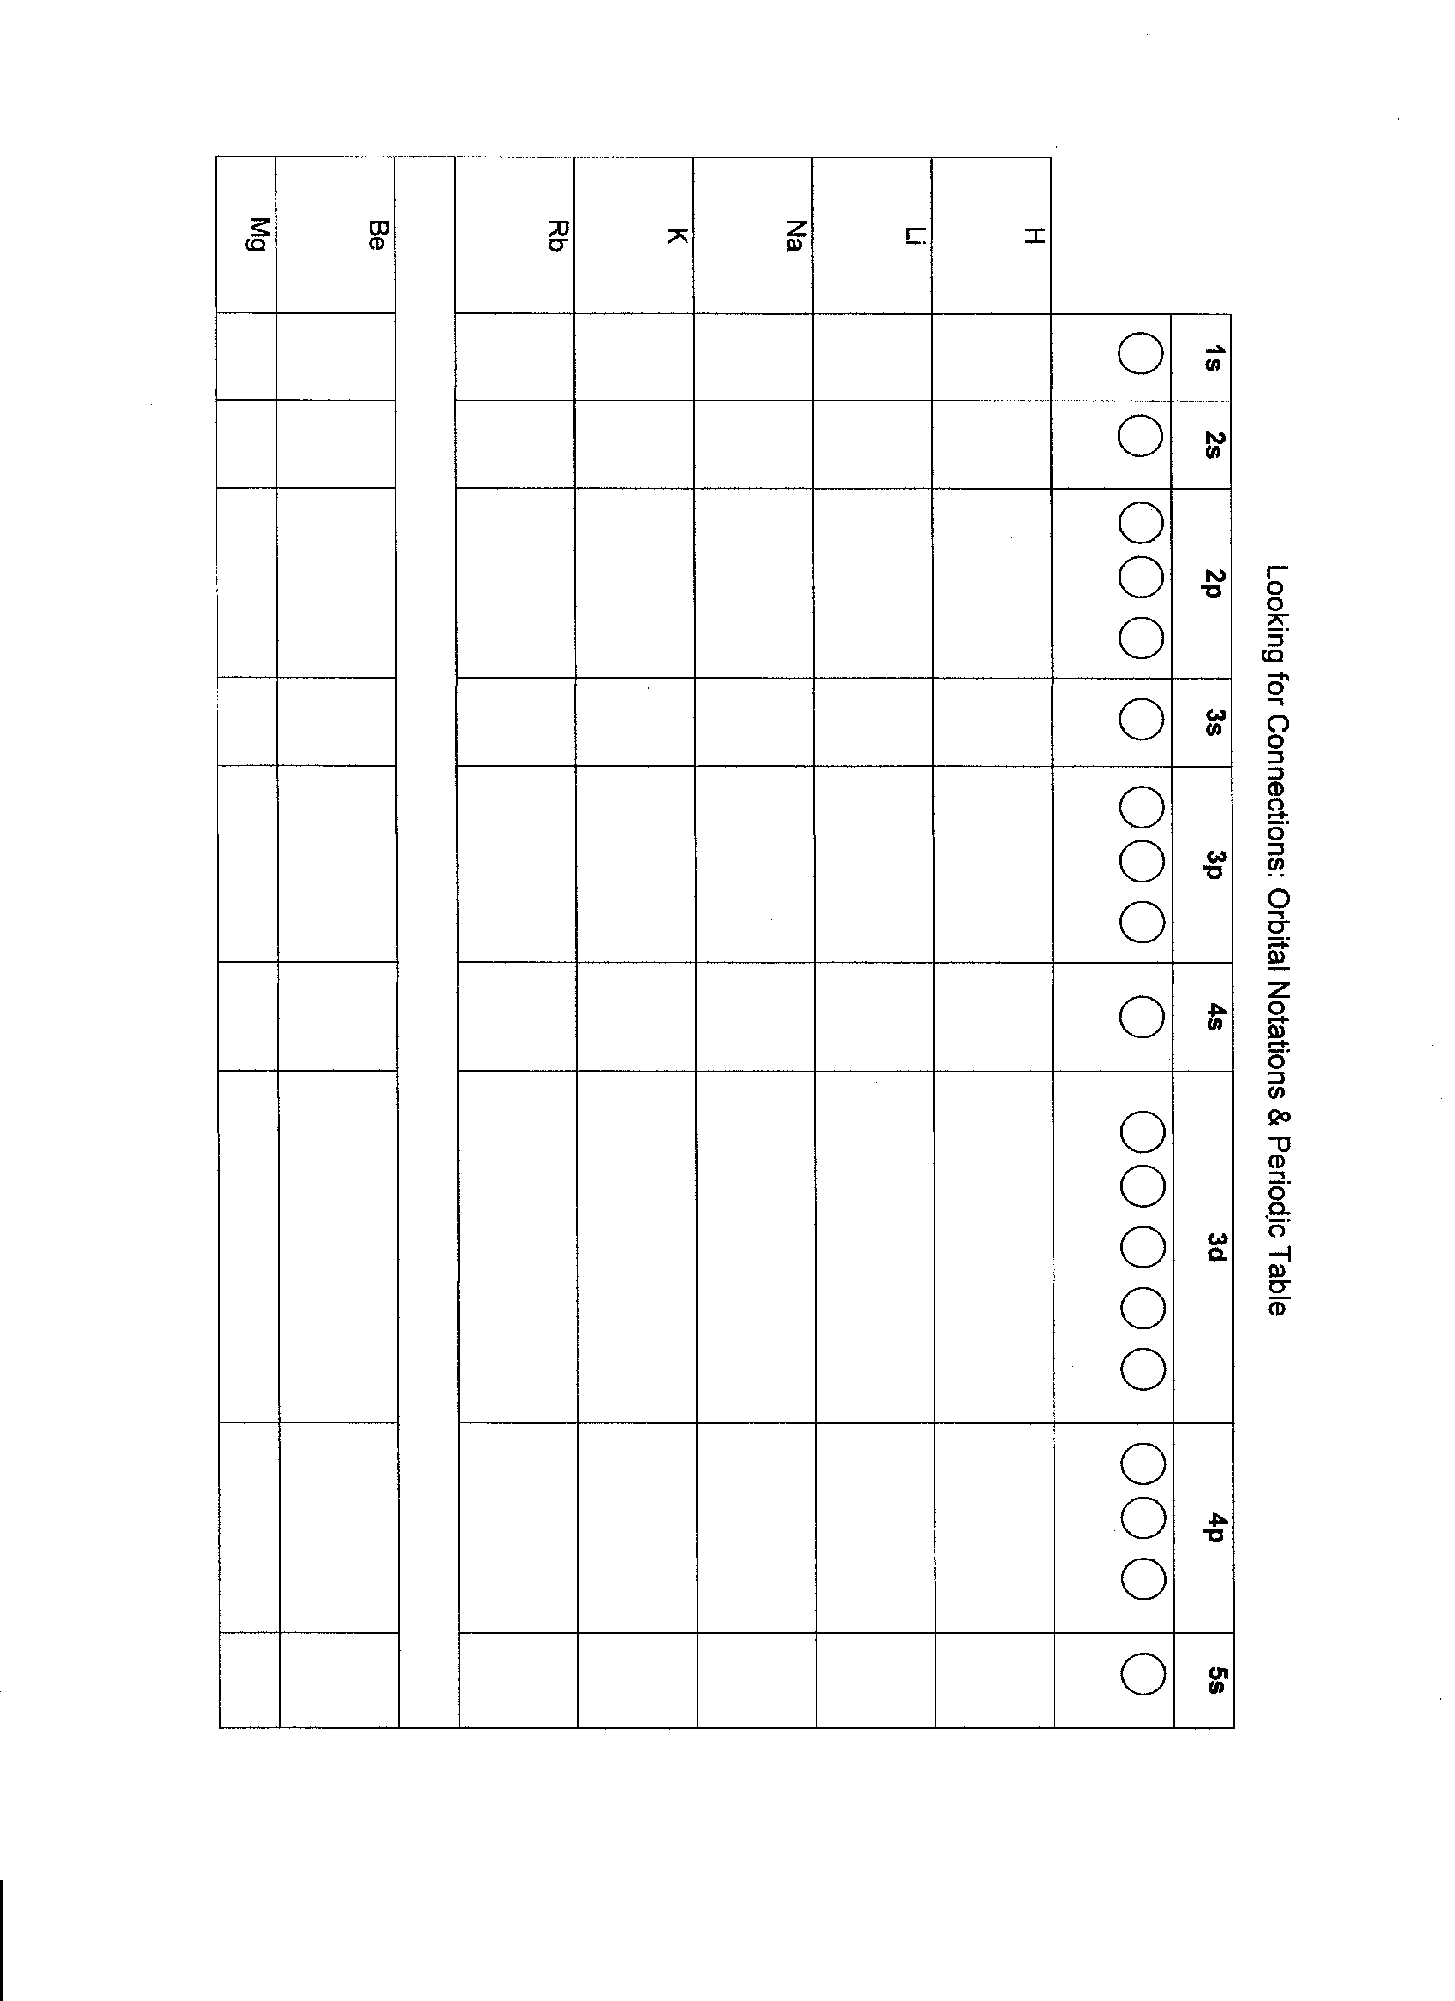
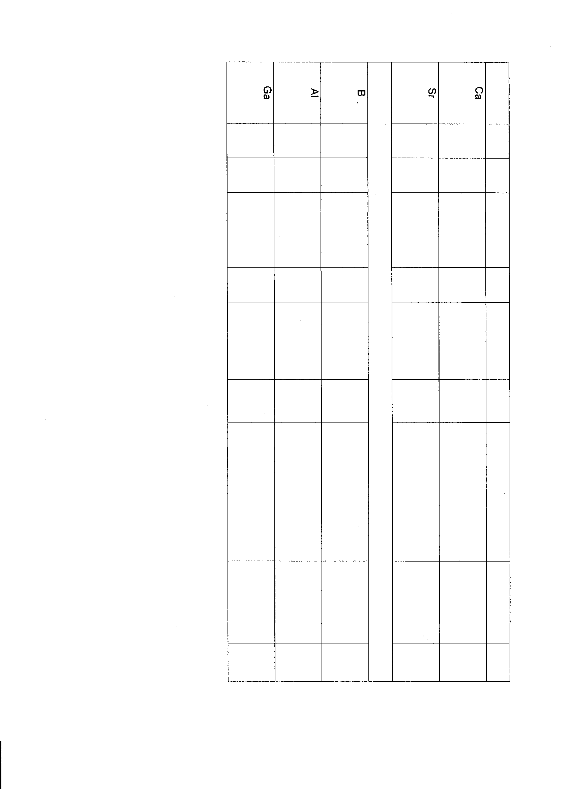
ELABORATE (honors): (30 minutes)

The teacher will use the Electrons notes as a guide for expanding the concepts in this unit to include quantum numbers for honors students. The information in parentheses applies to honors objective.

Essential Question:
How are quantum numbers assigned to electrons in a given element?

Electrons
- Quantum Numbers:
2.01-1 H
Apply quantum numbers to electron configurations.
**Honors objective notes are in parentheses
- n = Principal Quantum Number
- Represents the energy level – if n = 1, 1st energy level
- 2n² – determines maximum number of electrons that can occupy an energy level
-  = sublevel ( = 0 to n-1)
- Refers to different energy states in each energy level
- Number of sublevels = n
  - n = 1,  has 1 sublevel → s ( = 0)
  - n = 2,  has 2 sublevels → s ( = 0), p ( = 1)
  - n = 3,  has 3 sublevels → s ( = 0), p ( = 1), d ( = 2)
  - n = 4,  has 4 sublevels → s ( = 0), p ( = 1), d ( = 2), f ( = 3)
- m = orbital (m = - to )
- Space occupied by a pair of electrons
- s = 1 orbital (0)
- p = 3 orbitals (-1,0,1)
- d = 5 orbitals (-2, -1, 0, 1, 2)
- f = 7 orbitals (-3, -2, -1, 0, 1, 2, 3)
- s = spin
- in order for 2 electrons to occupy the same orbital, they must have opposite spins

Each arrow represents an electron (+ ½, -½)

Rules for placing electrons in orbitals
Aufbau Principal
- Electrons occupy orbitals of lowest energy first – 1s
Hund’s Rule
- Within a sublevel, orbitals are half-filled with electrons before they become filled
- p sublevel with 3 electrons

 | l | m | s | Honors (ex.)
1 | s | 1 |  | 1,0,0,+ ½  1,0,0,- ½
2 | s, p | 1, 3 |  | 2,0,0,+ ½  2,0,0,- ½  2,1,-1, + ½  2,1,-1, - ½  2,1,0, + ½  2,1,0, - ½  2,1,1, + ½  2,1,1, - ½
3 | s, p, d | 1, 3, 5
4 | s, p, d, f | 1, 3, 5, 7

EVALUATE: (20 minutes)

This Quantum Numbers Practice can be used to assess student understanding of assigning quantum numbers (honors).

Quantum Numbers Practice
Write quantum numbers for each of the following:
1. The fifth energy level _________________________
2. The 6s sublevel _________________________
3. An orbital on the 3d sublevel _________________________
4. The first electron added to the 4f sublevel _________________________
Indicate the maximum number of electrons in an atom that can have as part of their set of four quantum numbers:
5. n = 7 __________
6. n = 2, l = 1 __________
7. n = 4, l = 3, m = 2 __________
8. n = 7, l = 1, m = 2, s = -½ __________
9. n = 6, l = 0, m = 0, s = +½ __________
10. n = 4, l = 2, m = -3 __________
11. n = 7, l = 2 __________

12. Write each of the four sets quantum numbers that describe the 23 electrons of the ground state of Vanadium, V.

13. Write the 14 sets of quantum numbers that describe the 14 electrons of silicon.

EXPLAIN: (15 min.)
Upon completion of the activity, allow the students the opportunity the concept of average atomic mass and how they derived their answers.

EVALUATE:
Sample Assessment Questions:
Unit | Goal/ RBT Tag | Questions
3 | 4.01  B4  B4 | 1. Identify which of the following types of electromagnetic radiation has the greatest frequency:  A. Infrared  B. Microwaves  C. Ultraviolet  D. X-rays  2. Identify the wavelength of light emitted when an electron transitions from n=4 to n=2.  A. 1282 nanometers  B. 656 nanometers  C. 486 nanometers  D. 103 nanometers
 | 3.01  C4  C4 | 1. Identify the element with the following electron configuration: 1s²2s²2p⁶3s²3p³  A. aluminum  B. carbon  C. phosphorus  D. sulfur  2. Determine the number of valence electrons of an element that has the electron configuration of 1s²2s²2p⁶3s²3p⁵.  A. 3  B. 5  C. 7  D. 17

EVALUATE: (45 minutes)

Below are sample test items obtained from WIZARD that can be used to allow students to assess their understanding and abilities and also allow the teacher to evaluate the students understanding of key concepts and development of skills.

