Chemistry Exam Review Part I

Atomic Theory and Atomic Structure
Dalton | Today, Modern

Matter is composed of very tiny or
microscopic particles called
“Atoms”. An indivisible particle which can never be created nor destroyed.

Atoms of an element are identical
in size, shape, mass, and in other
properties.

Atoms of different elements are
different in their properties.
Atoms combine with each other in small while numbers.
Person | Experiment | Focus
Democritus |  | “Atom”
Dalton |  | Atomic Theory
J. J. Thomson | Cathode ray tube | Negative and positive regions, electrons exist
Rutherford | Gold Foil | Small, positively charged center (nucleus)
Bohr |  | Electrons in specific energy levels
Chadwick |  | neutron
Milliken | Oil Drop | Electron’s exact charge and mass
Newest Model = Quantum Model |  | Electrons are in an electron cloud
- What did Rutherford’s gold foil experiment tell us about the structure of the atom?

- Draw the Bohr Model of the atom for sodium.

- Distinguish between mass number and atomic number.

- List the subatomic particles with charge, location, and approximate mass.

- Why is there an average atomic mass on the periodic table?

- Complete the following table.
Hyphen notation | Element | # of Protons | Mass # | # of Electrons | Atomic Number | # of Neutrons | Isotope, Ion, or Neutral
 | Hydrogen |  |  |  |  |  | neutral
C– 14 | Carbon |  | 14
 |  | 19 |  | 18
 |  |  |  |  | 3 |  | neutral
Cl – 37 |  |  |  |  |  |  | Ion, isotope

- Referring to the reference table for the Bohr model for the following questions
  - For n = 1 an electron is at its ground state if it jumps up to level 4, what state is it? _______________
  - If the same electron drops back to its ground state, the light energy emitted is in which general region of the Electromagnetic spectrum _______________________
  - Where is visible light located in the region of the electromagnetic spectrum in meters? ______________

The Periodic Table and Periodic Trends

- Electronegativity –

Trend: down a group __________________ across a period __________________
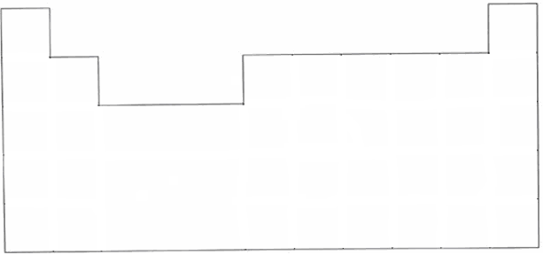

- Ionization energy –

Trend: down a group __________________ across a period __________________
- Atomic radius –

Trend: down a group __________________ across a period __________________

- Ionic radius –

Trend for positive ion: down a group __________________ across a period __________________
Trend for negative ion: down a group __________________ across a period __________________

Reasoning Behind Periodic Trends:

Down a group – more energy levels, electrons farther away from positive nucleus, pulled less tightly

Across a period – same energy level, but more protons, protons pull electrons in more tightly,
increased effective nuclear charge

Applying Trends:

Put the following elements in order from largest to smallest according to the specified trend.
- Electronegativity – P, Ga, O, Ba ________________________________

- Ionization Energy – Cl, Mg, Si, Sr ________________________________

- Atomic Radii – C, Rb, F, Na ________________________________

How does a cation’s size compare to the size of its parent atom?

Li Li⁺

How does an anion’s size compare to the size of its parent atom?

N N³⁻

Groups, Periods
1 18
1A 8A

2 13 14 15 16 17
2A 3A 4A 5A 6A 7A

_____ _____ _________________ _____ _____ _____ _____ _____ _____

A groups (groups 1-2, 13-18) are called the _______________________________________

B groups (groups 3-12) are called the ___________________________________________

List the group number for each of the following:
alkali metals _______________
alkaline earth metals _______________
halogens _______________
noble gases _______________

How many valence electrons are in each of the following?
Na K B N O Se Cl

What is the oxidation number of each of the following?
Na K B N O Se Cl

Electron Configuration

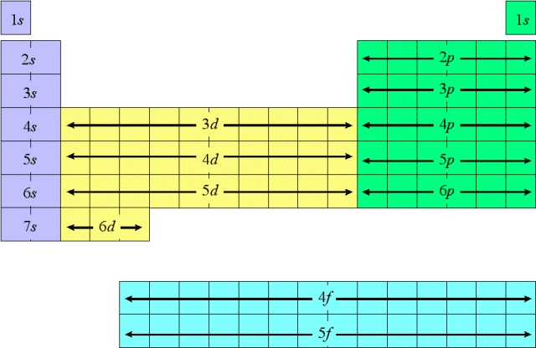

What element?

1s¹ ________ 1s²2s²2p⁶3s²3p⁵ ________ [He]2s¹ ________ [Ar]4s²3d⁸ ________

How many valence electrons?

1s² _______ 1s²2s²2p⁶3s²3p⁶ _______ [Ne]3s² _______ [Ar]4s²3d¹⁰4p³ _______

What oxidation number?

1s¹ _______ 1s²2s²2p⁴ _______ [He]2s¹ _______ [Ar]4s²3d⁸ _______

Number of electrons lost or gained to make a stable ion?

1s²2s²2p⁶3s²3p⁵ _______ [Ne]3s² _______ [Ar]4s²3d¹⁰4p³ _______

Write the electron configuration and draw the electrons for the orbital notation of NITROGEN

_______ _______ _______ _______ _______ _______ _______ _______

