Chemistry Exam Review Part III
Mole Concept and Stoichiometry
- In order to make 12.0 L of 0.250 M HCl.
a) How many moles must be used?

b) How many molecules of HCl must be used?

c) How many grams of HCl must be used?

- Given 44.8 L of O₂ at STP, calculate
a) The number of moles

b) The mass in grams

c) The number of molecules

- Given 73.0 g of hydrochloric acid and excess zinc, how many liters of hydrogen gas will form at STP?

- What is the empirical formula for a compound that is 92.3% C and 7.7% H?

- What is the empirical formula for a compound that has 36.5 g of sodium, 25.4 g of sulfur, and 38.1 g of oxygen?

- What is the molecular formula for a compound with an empirical formula of CoC₄O₄ and the molecular weight 341.94 g/mol?

- Determine the percent composition of tin in tin (IV) oxide.

Gas Laws
- What is the volume (in liters) of a gas with the pressure of 0.980 atm, a temperature of 68°C, and 0.120 mol?

- How many grams of nitrogen dioxide are necessary to produce 0.119 mL of gas at -15°C and 500 kPa of pressure?

1mol of gas = _______________L

- 43.5 L CO₂ = ____________mol CO₂

- 8.23 g of NO = _____________L NO

According to Avogadro’s Law, the number of moles of gas are proportional to the ___________ of a gas. Therefore, as the number of moles ______________, the volume ________________.
If given 22.4 L = 1mole, then 44.8 L = _______moles.
- A scientist has a sample of gas collected several days ago. The final volume of the gas is 392 mL at a pressure of 0.977 atm and a temperature of 21°C. Its initial temperature was 13°C and had a pressure of 0.992 atm. What was the initial volume of the gas?

- Oxygen gas is collected over water at a temperature of 10°C and a pressure of 1.02 atm. The volume of gas plus water vapor collected is 293 mL. What volume of oxygen at STP was collected?

- A sample of nitrogen gas is collected over water, yielding a total volume of 62.25 mL at a temperature of 22°C and a total pressure of 97.7 kPa. At what temperature will the nitrogen end at if the volume is 50.00 mL at the same pressure?
- Dalton’s law is defined as each individual gas pressure added together to give you the _________ _________.The formula for Dalton’s law is: _________________________.

- ]Some chlorine gas is collected over water with a pressure of 153.5 kPa. The total pressure
of the sample is 156.5 kPa. What is the pressure of the water vapor?

- Does the solubility of a gas increase or decrease with temperature? _______________________

- Draw a graph and describe the relationship between amount of dissolved gas and temperature.

- Know that vapor pressure of water is a function of temperature (as temperature increases the vapor pressure increases)

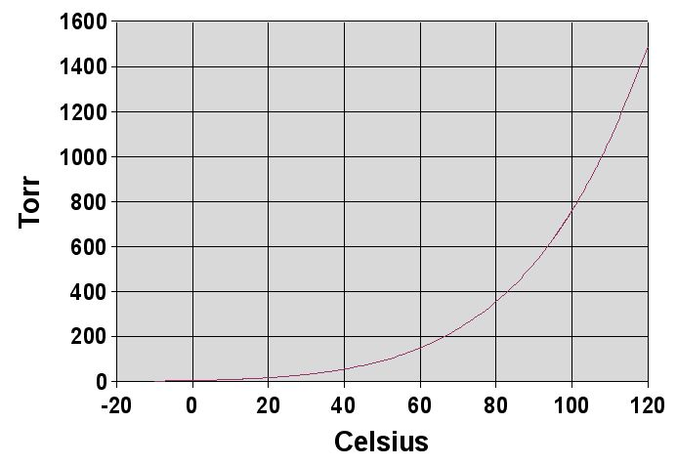
There is a ___________________ relationship between vapor pressure and temperature. As the temperature goes up, the vapor pressure goes __________.

